**Hospital data analysis using SQL**

**1. Get a list of Patients in order by DateOfBirth descending order**

select concat ("FirstName", ' ', "LastName") as FullName , date_part('year', age("DateOfBirth")) as Age

from public."Patients"

order by Age DESC;

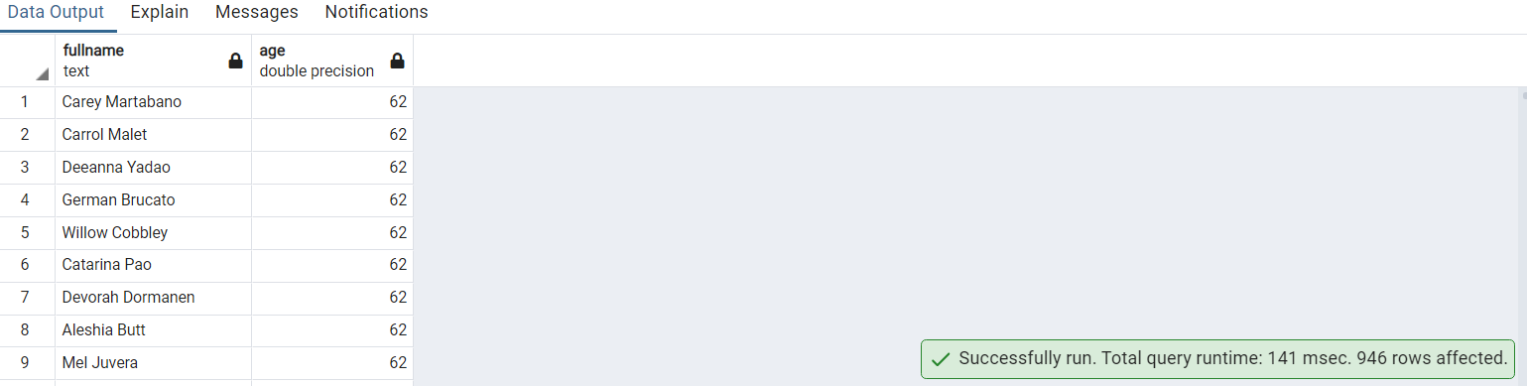

**2. Display the first name and Lastname of patients who speaks the English language.**

select p."FirstName",p."LastName"

from public."Patients" p

inner join public."Language" l On p." Language_ID" = l."Language_ID"

where "Language"='English';

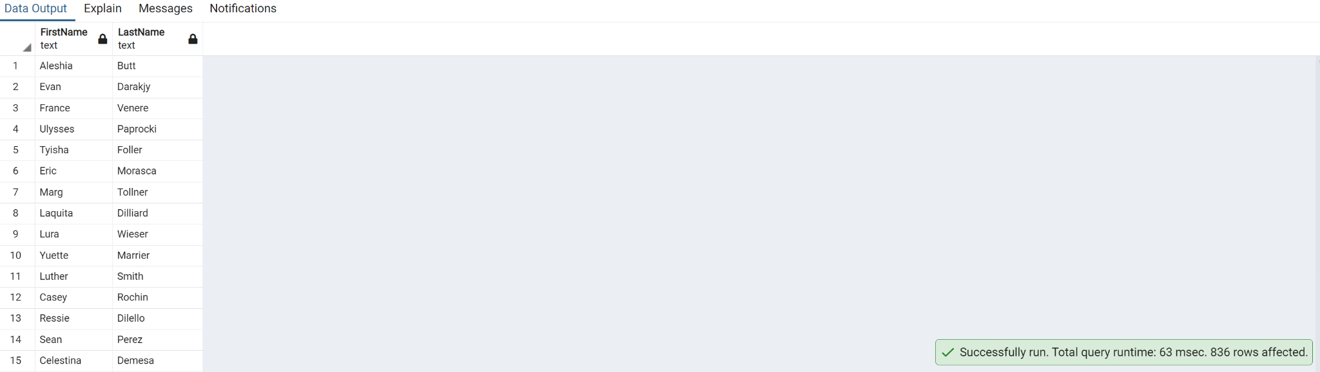

**3. Write a query to get a list of patient IDs whose PrimaryDiagnosis is 'Flu'.order by patient_ID**

select r."Patient_ID",p."PrimaryDiagnosis"

from the public."ReAdmissionRegistry" r

inner join public." PrimaryDiagnosis" p on r."Diagnosis_ID" = p."Diagnosis_ID"

where p."PrimaryDiagnosis" = 'Flu'

order by r."Patient_ID";

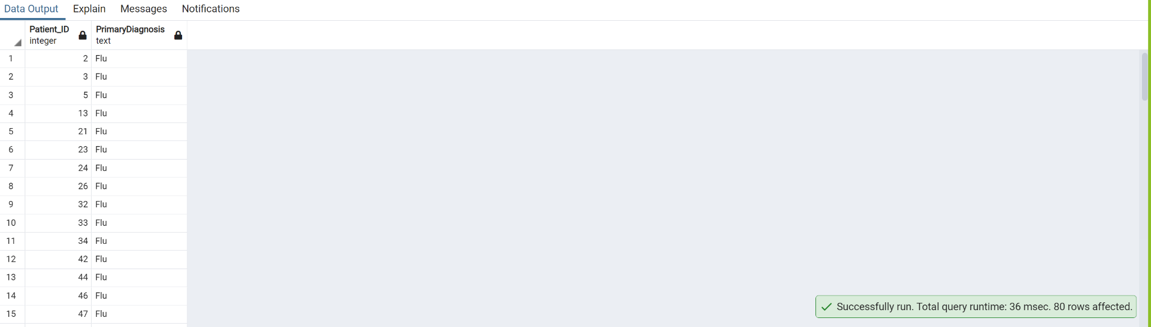

**4. Write a query to find the Patient_ID and Admission_ID for the patients whose Primary diagnosis is 'Heart Failure'**

select d."Patient_ID", d."Admission_ID",p."PrimaryDiagnosis"

from the public."Discharges" d

inner join public." PrimaryDiagnosis" p on d."Diagnosis_ID" = p."Diagnosis_ID"

where p."PrimaryDiagnosis" = 'Heart Failure'

order by d."Patient_ID";

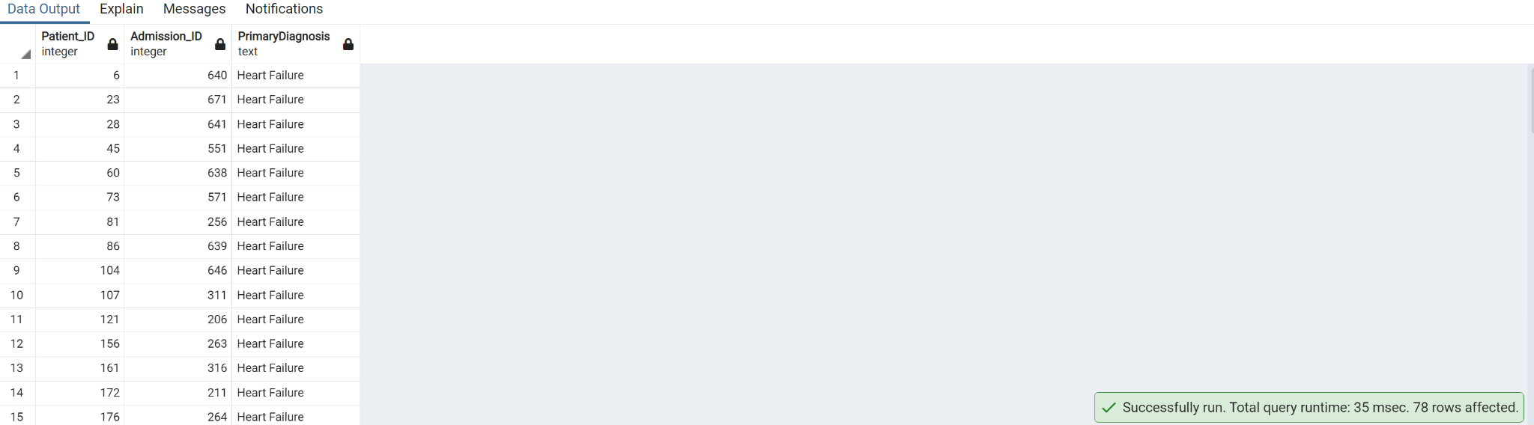

**5. Write a query to get a list of patient IDs whose pulse is below the normal range**

select "Patient_ID",ROUND("Pulse")

from the public."AmbulatoryVisits"

where "Pulse"< 60

order by ROUND("Pulse");

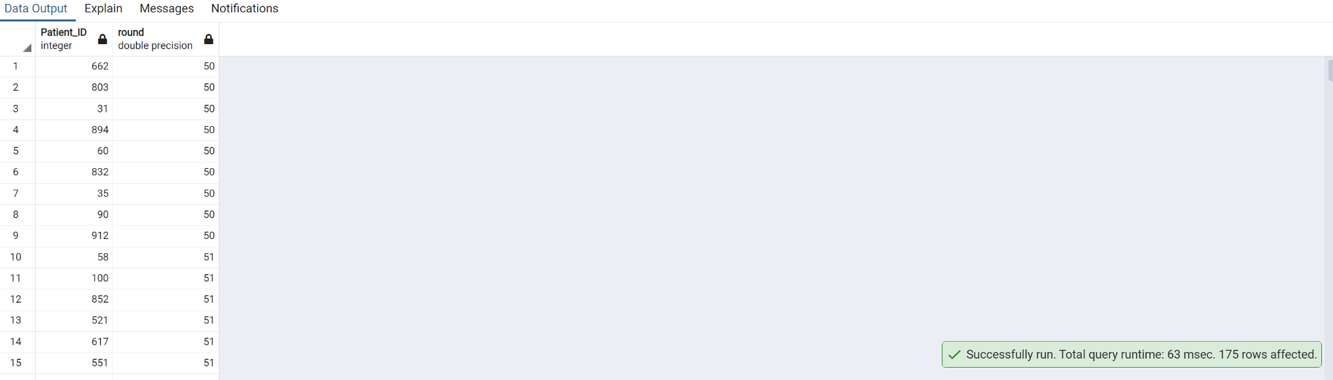

**6. Write a query to find the list of patient_ID's discharged with Service in SID01, SID02, and SID03.**

select d."Patient_ID",s."Service_ID",s."Service"

from the public."Discharges" d

inner join public."Service" s on s."Service_ID"=d."Service_ID"

where s."Service_ID" in ('SID01', 'SID02', 'SID03')

order by s."Service_ID";

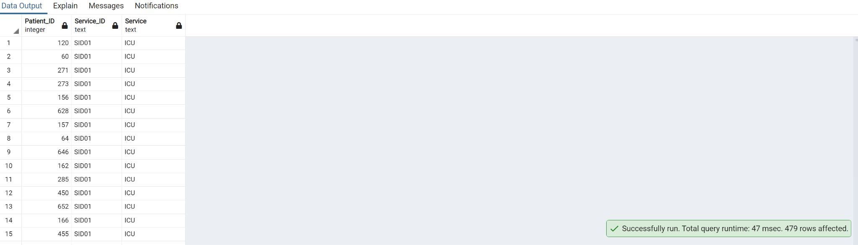

**7. Write a query to get a list of patients who were admitted because of Stomachache.**

select p."FirstName",p."LastName",r."ReasonForVisit"

from public."Patients" p

inner join public." EDVisits" ed on p." Patient_ID"=ed."Patient_ID"

inner join public." ReasonForVisit" r on ed."Rsv_ID"=r."Rsv_ID"

where r."ReasonForVisit"='Stomach Ache';

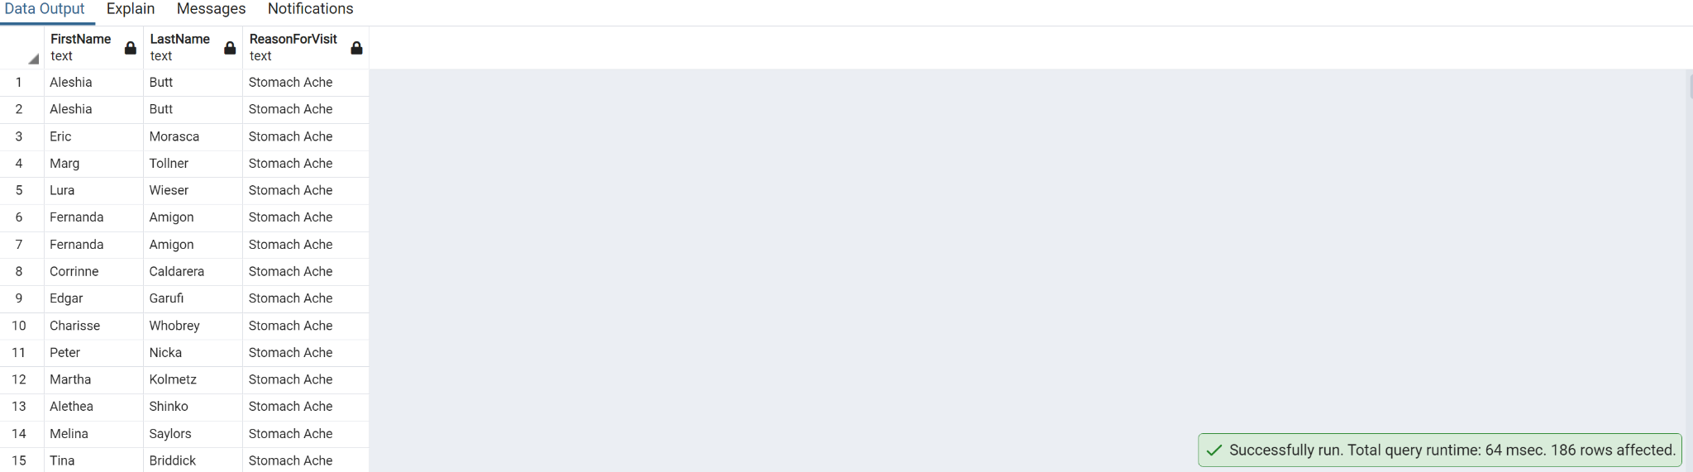

**8. Write a query to Update Service ID SID05 to Ortho**

Update public."Service"

set "Service" =' Ortho'

where public."Service"."Service_ID"='SID05';

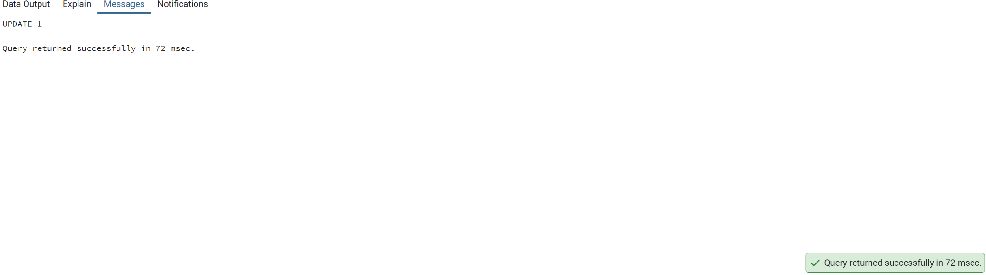

**9. Get a list of Patient IDs whose visit type was 'Followup' and VisitdepartmentID is 5 or 6**

select a."Patient_ID",v."VisitType",a."VisitDepartmentID"

from the public."AmbulatoryVisits" a

inner join public."VisitTypes" v on a."AMVT_ID"=v."AMVT_ID"

where v."VisitType"='Follow Up' and a."VisitDepartmentID" in (5, 6)

order by a."VisitDepartmentID";

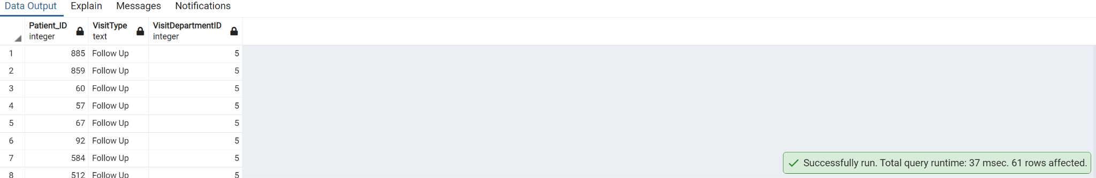

**10. Create an index on an ambulatory visit by selecting columns Visit_ID, AMVT_ID and VisitStatus_ID**

CREATE INDEX indx_AmbulatoryVisits

ON public."AmbulatoryVisits" ("Visit_ID", "AMVT_ID", "VisitStatus_ID");

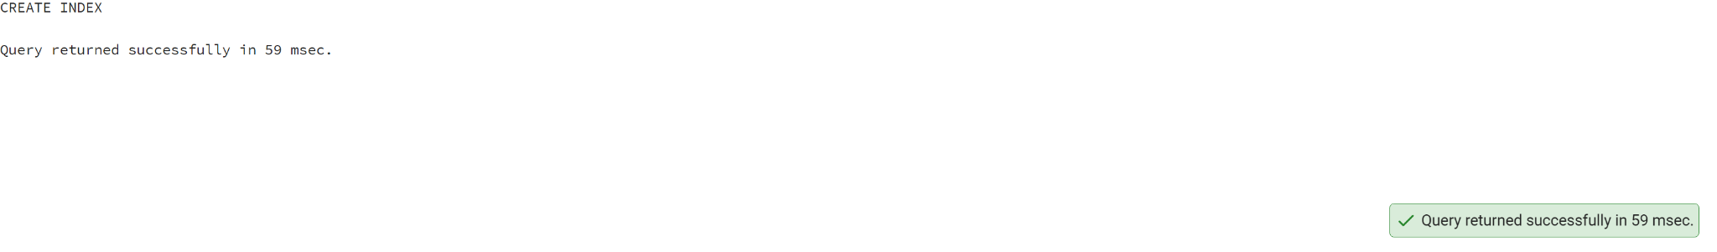

**11. Create a trigger to execute after inserting a record into the Patients table. Insert value to display result.**

CREATE TABLE IF NOT EXISTS public."Patients_new"

(

"Patient_ID" integer NOT NULL,

"FirstName" text,

"LastName" text,

"DateOfBirth" date,

"Gender_ID" text,

"Race_ID" text,

"Language_ID" text

);

CREATE OR REPLACE FUNCTION public." Patients_fuct"()

RETURNS trigger AS

$$

BEGIN

INSERT INTO public."Patients_new"("Patient_ID", "FirstName", "LastName", "DateOfBirth", "Gender_ID", "Race_ID", "Language_ID")

VALUES(NEW."Patient_ID", NEW."FirstName", NEW."LastName", NEW."DateOfBirth", NEW."Gender_ID", NEW."Race_ID", NEW."Language_ID");

RETURN NEW;

END;

$$

LANGUAGE 'plpgsql';

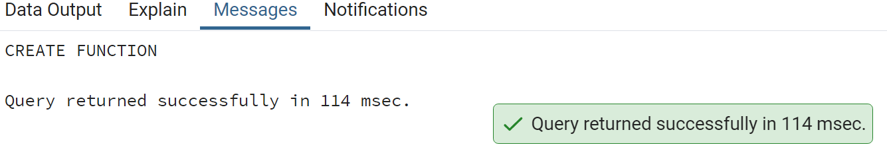

CREATE TRIGGER patients_tri

AFTER INSERT

ON public."Patients"

FOR EACH ROW

EXECUTE PROCEDURE public."Patients_fuct"();

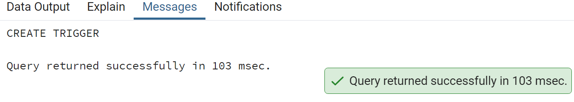

INSERT INTO public."Patients"

("Patient_ID", "FirstName", "LastName", "DateOfBirth", "Gender_ID", "Race_ID", "Language_ID")

VALUES (10000, 'Priya', 'sowale', '1990-01-01', 'G001', 'R01', 'L_01');

Select * from public."Patients_new";

**12. Write a query to find the ProviderName and Provider Speciality for PS_ID =' PSID02'**

select p."ProviderName",ps."PS_ID",ps."ProviderSpeciality"

from the public."Providers" p

inner join public." ProviderSpeciality" ps on ps."PS_ID"=p."PS_ID"

where ps."PS_ID"= 'PSID02';

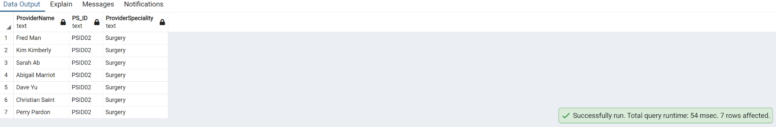

**13. Display the patient names and ages whose age is more than 50 years**

SELECT CONCAT("FirstName",' ', "LastName") AS FullName , date_part('year', age("DateOfBirth")) AS Age

FROM public."Patients"

WHERE date_part('year', age("DateOfBirth")) > 50

order by date_part('year', age("DateOfBirth"));

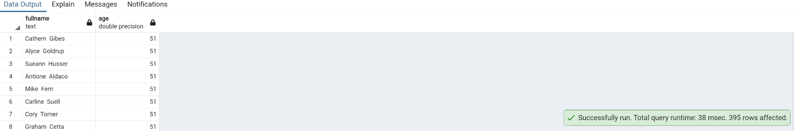

**14. Write a query to get a list of patient ID'sand services whose are in service as 'Neurology'**

SELECT r."Patient_ID",s."Service"

FROM public."Service" s

INNER JOIN public."ReAdmissionRegistry" r ON s."Service_ID" =r."Service_ID"

where s."Service" = 'Neurology'

order by r."Patient_ID";

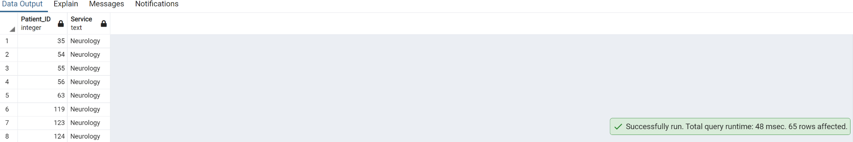

**15. Create view on table Provider table on columns ProviderName and Provider_ID**

CREATE VIEW "Provider_public" AS

SELECT "ProviderName", "Provider_ID"

FROM public."Providers";

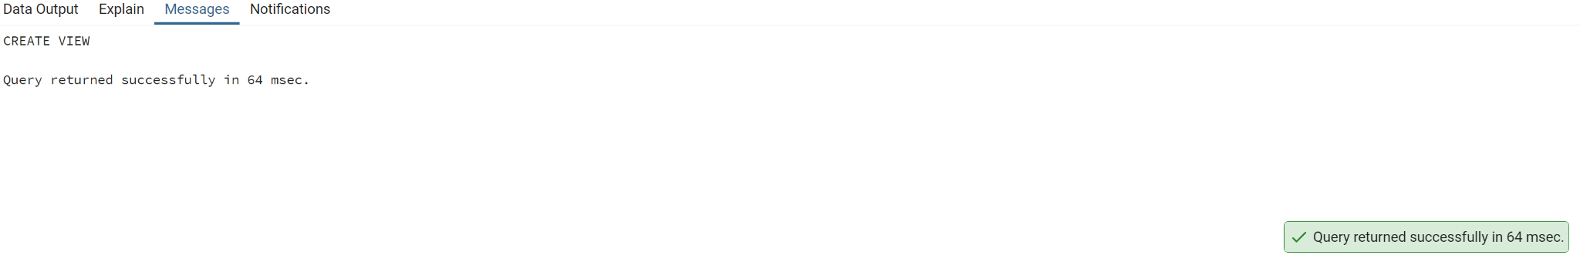

**16. Write a query to Extract Year from ProviderDateOnStaff**

select extract (year from "ProviderDateOnStaff" ) from public."Providers";

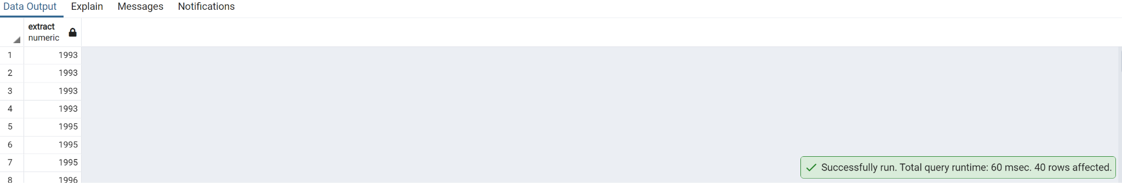

**17. Write a query to get unique Patient_ID,race and Language of patients whose race is White and also speak English.**

select distinct p."Patient_ID",r."Race_ID",l."Language"

from public."Patients" p

inner join public."Race" r on p."Race_ID"=r."Race_ID"

inner join public."Language" l on l."Language_ID"=p."Language_ID"

where "Race"='White' and "Language"='English';

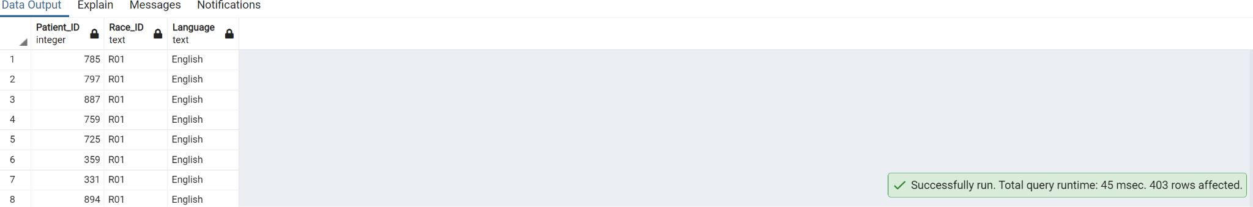

**18. Get list of patient ID's whose service was 'Cardiology' and discharged to 'Home'**

select d."Patient_ID", s."Service",dp."DischargeDisposition"

from public."Discharges" d

inner join public."Service" s on s."Service_ID"=d."Service_ID"

inner join public."DischargeDisposition" dp on dp."Discharge_ID"=d."Discharge_ID"

where "Service" ='Cardiology' and "DischargeDisposition"='Home';

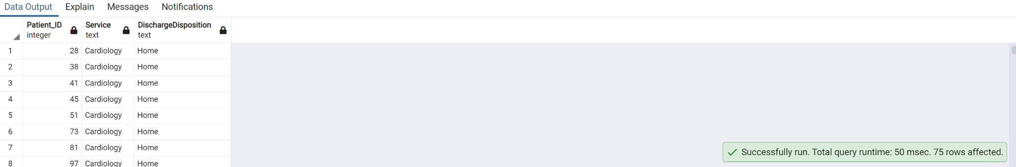

**19. Write a query to get list of Provider names whose Providername is starting with letter T**

select "ProviderName" from public."Providers" where upper("ProviderName") like 'T%';

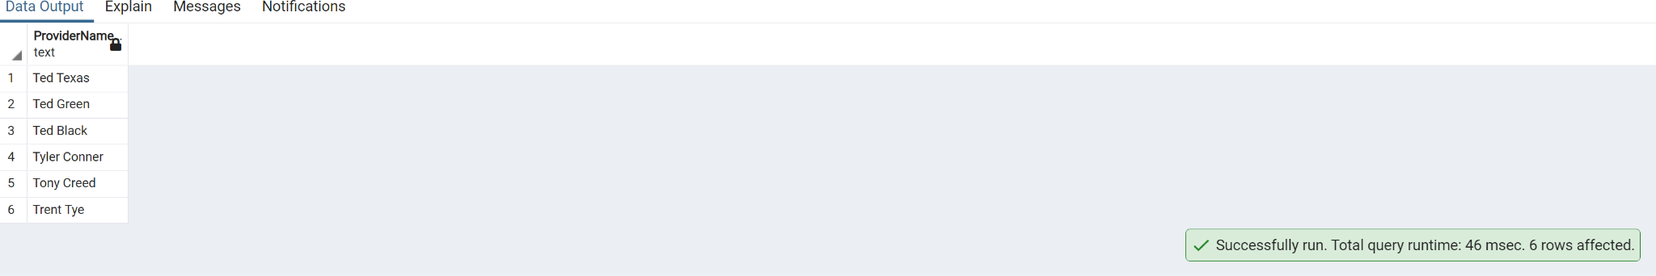

**20. List female patients over the age of 40 who have undergone surgery from January-March 2019**

select "FirstName","LastName",date_part('year',Age(now(),"DateOfBirth")) as Age,"DateofVisit","ProviderSpeciality",VS."VisitStatus"

from public."Patients" PA

join public."AmbulatoryVisits" AV on PA."Patient_ID" = AV."Patient_ID"

join public."Providers" PR on AV."Provider_ID"=PR."Provider_ID"

join public."ProviderSpeciality" PS on PR."PS_ID" = PS."PS_ID"

join public."VisitStatus" VS on AV."VisitStatus_ID" = VS."VisitStatus_ID"

where "Gender_ID" = 'G002' and date_part('year',Age(now(),"DateOfBirth"))>40 and "ProviderSpeciality" = 'Surgery' and VS."VisitStatus_ID" = 'VS002'

and "DateofVisit" between '2019-01-01' and '2019-03-31' order by "DateofVisit"

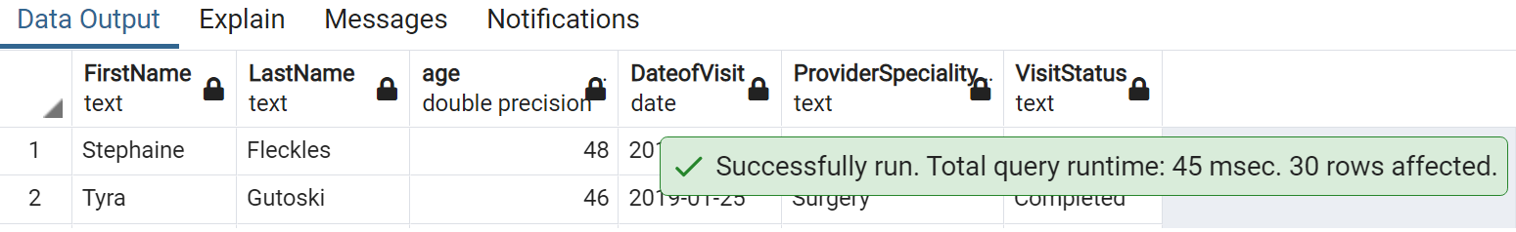

**21. Write a Query to get list of Male patients.**

select p."FirstName",p."LastName", g."Gender"

from public."Patients" p

inner join "Gender" g on p."Gender_ID"=g."Gender_ID"

where "Gender"='Male';

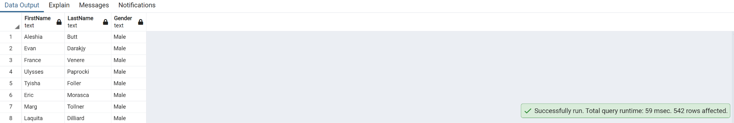

**22. Write a query to get list of patient ID's who has discharged to home.**

select d."Patient_ID",dp."DischargeDisposition"

from public."Discharges" d

inner join public."DischargeDisposition" dp on dp."Discharge_ID"=d."Discharge_ID"

where "DischargeDisposition"='Home';

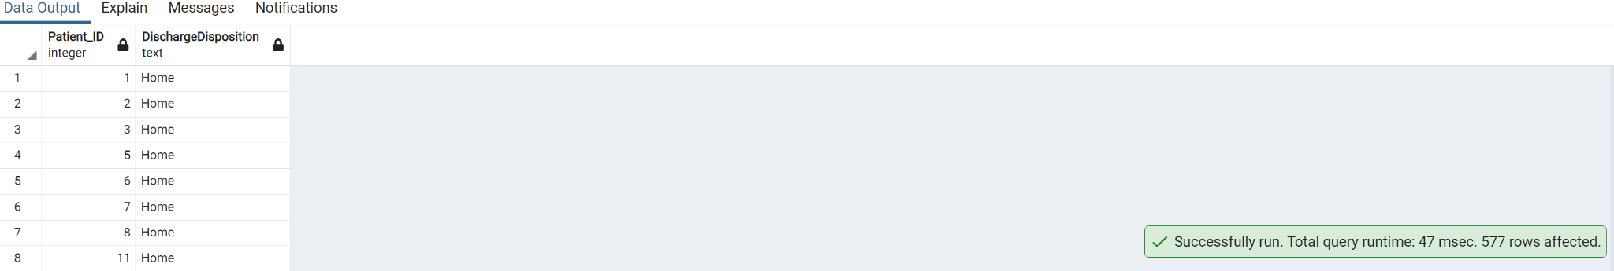

**23. Find the category of illness(Stomach Ache or Migraine) that has maximum number of patients**

Select "ReasonForVisit", count(*) As "Total_Number_Patients"

from public."Patients" p

inner join public."EDVisits" ed on p."Patient_ID" = ed."Patient_ID"

inner join public."ReasonForVisit" rv on ed."Rsv_ID" = rv."Rsv_ID"

where "ReasonForVisit" in ('Stomach Ache', 'Migraine')

group by "ReasonForVisit"

order by "Total_Number_Patients" DESC

limit 1;

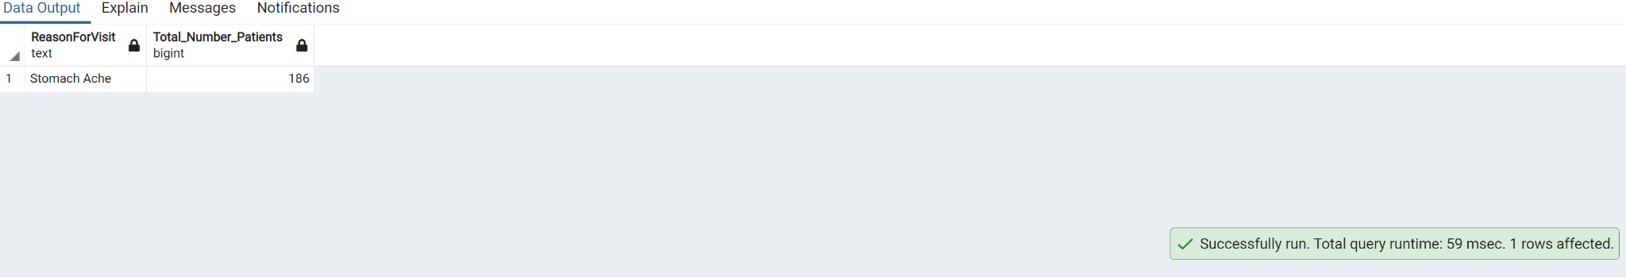

**24. Write a query to get list of New Patient ID's.**

select p."Patient_ID"

from public."Patients"p

inner join public."AmbulatoryVisits" a on a."Patient_ID"=p."Patient_ID"

inner join public."VisitTypes" v on v."AMVT_ID"=a."AMVT_ID"

where "VisitType"='New';

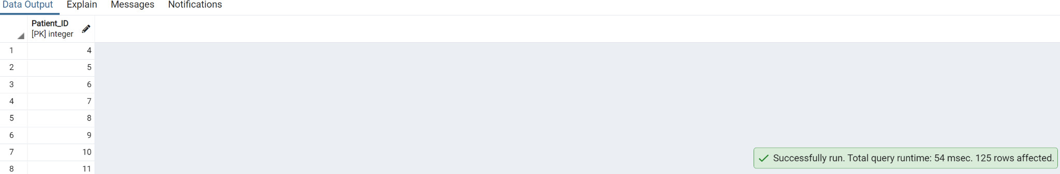

**25. Create trigger on table Readmission registry**

Create trigger ReAdmission_Trigger

BEFORE UPDATE

ON public."ReAdmissionRegistry"

FOR EACH ROW

EXECUTE PROCEDURE ReAdmission_function();

CREATE FUNCTION ReAdmission_function()

RETURNS trigger as

$$

BEGIN

IF Patient_ID=1 THEN

UPDATE Patients."ReadmissionEntry"

SET NEW."Discharge_ID"='DID11';

END IF;

RETURN NEW;

END;

$$

LANGUAGE 'plpgsql';

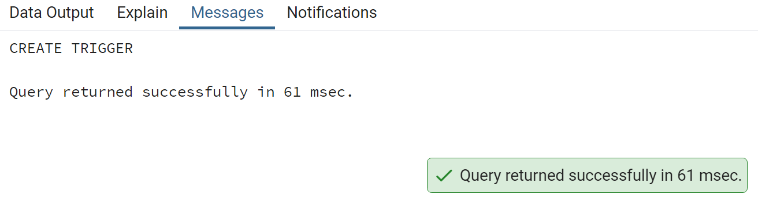

**26. Select all providers with a name starting 'h' followed by any character , followed by 'r', followed by any character,followed by 'y'**

select "ProviderName"

from public."Providers"

where "ProviderName" like 'h_r_y';

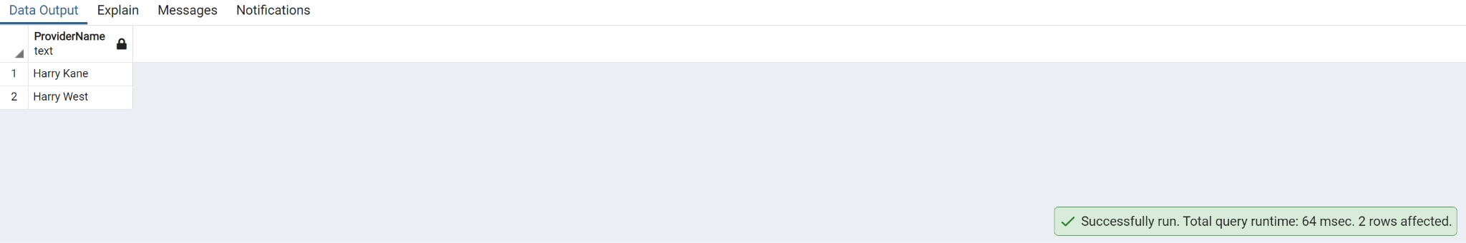

**27. Show the list of the patients who have cancelled their appointment**

select p."FirstName",p."LastName"

from public."Patients" p

inner join public."AmbulatoryVisits" a on a."Patient_ID"=p."Patient_ID"

inner join public."VisitStatus" v on v."VisitStatus_ID"=a."VisitStatus_ID"

where v."VisitStatus"='Canceled';

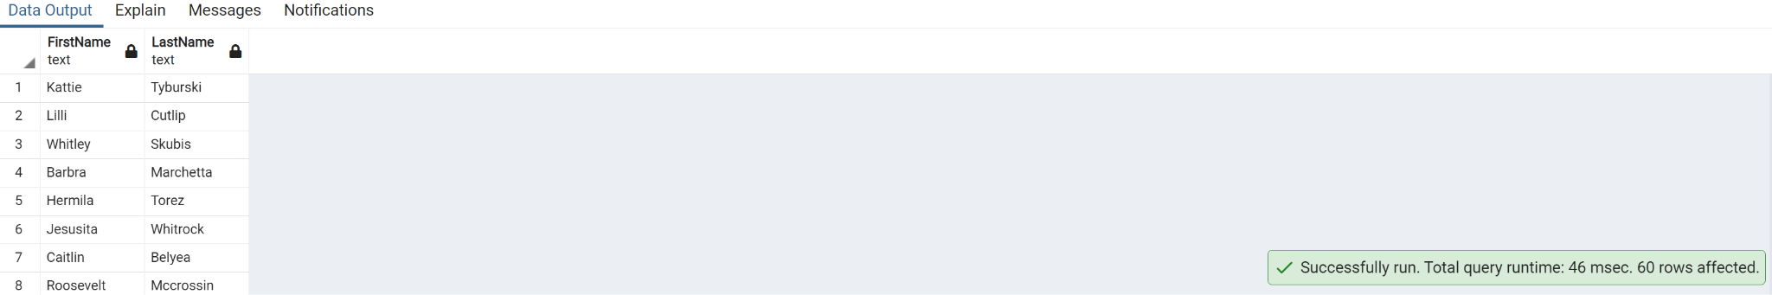

**28. Write a query to get list of ProviderName's with a name starting 'ted'**

select "ProviderName"

from public."Providers"

where lower("ProviderName") like 'ted%';

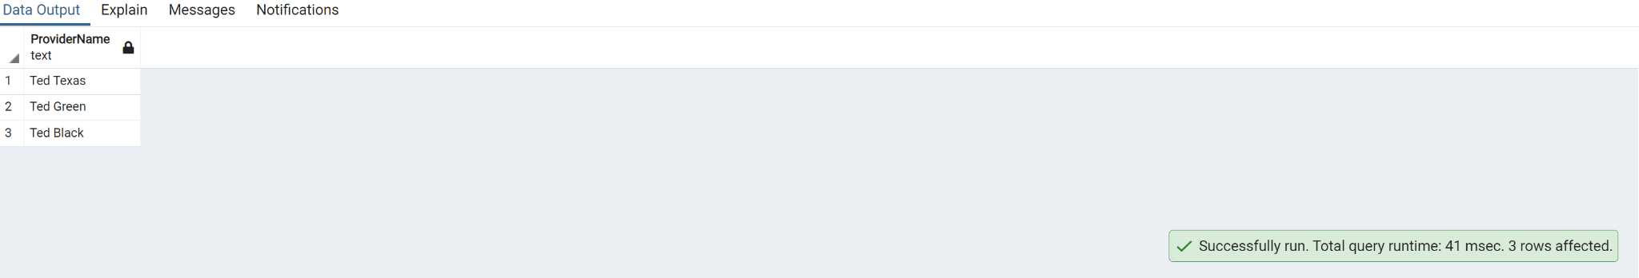

**29. Create a view without using any schema or table and check the created view using select statement**

CREATE VIEW "Welcome" AS SELECT 'Welcome to NumpyNinja' AS "Welcome_Message";

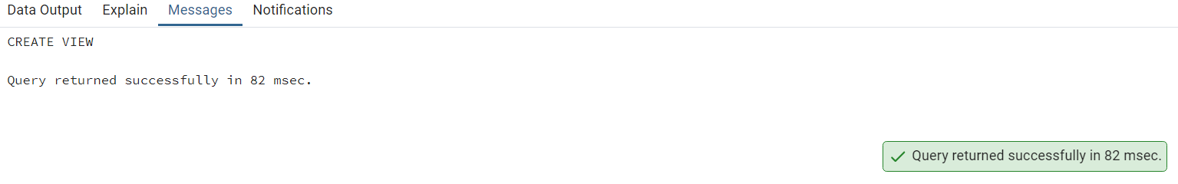

SELECT *

FROM "Welcome" ;

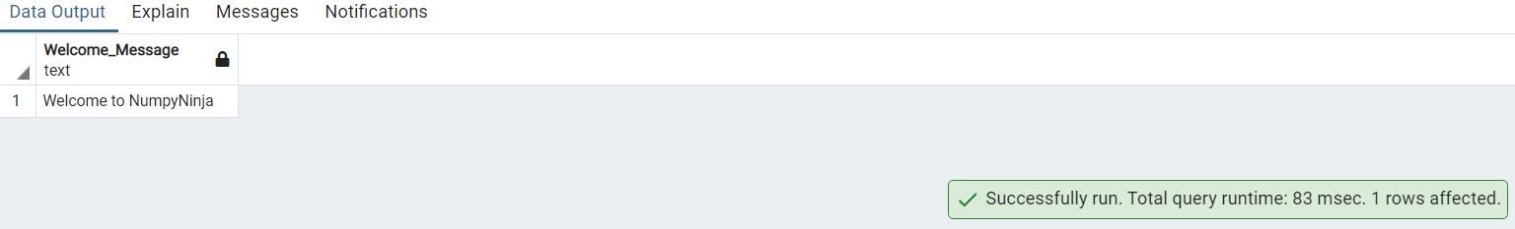

**30. Write a query to get unique list of Patient Id's whose reason for visit is car accident.**

select distinct ed."Patient_ID" ,rv."ReasonForVisit"

from public."EDVisits" ed

inner join public."ReasonForVisit" rv on rv."Rsv_ID"=ed."Rsv_ID"

where "ReasonForVisit"='Accident'

order by ed."Patient_ID";

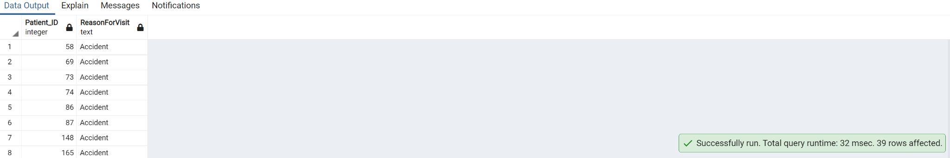

**31. Find which Visit type of patients are maximum in canceling their appointment**

select "VisitType", count(*) As "Total_Number_Patients"

from public."VisitTypes" vt

inner join public."AmbulatoryVisits" a ON vt."AMVT_ID"=a."AMVT_ID"

inner join public."VisitStatus"vs ON a."VisitStatus_ID"=vs."VisitStatus_ID"

where "VisitStatus"='Canceled'

group by "VisitType"

order by "Total_Number_Patients" DESC

limit 1;

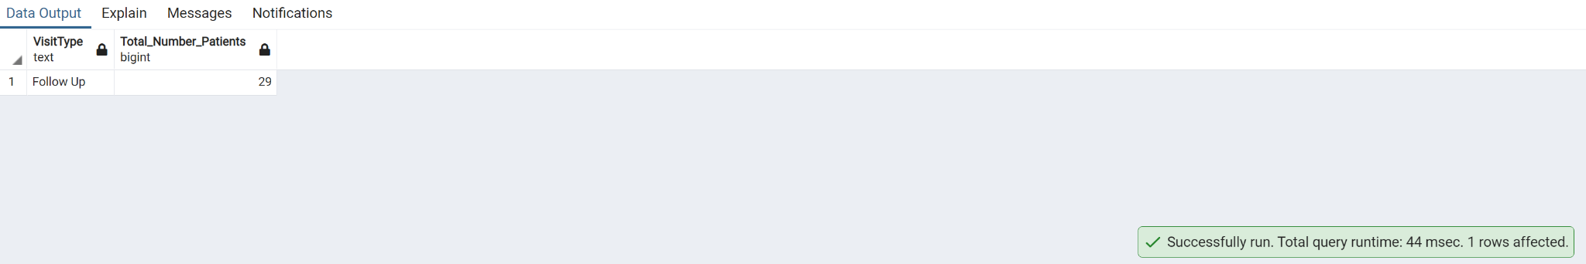

**32. Write a query to Count number of patients by VisitdepartmentID where count is greater than 50**

select "VisitDepartmentID", count(*) as "number_of_patient" from public."AmbulatoryVisits"

group by "VisitDepartmentID"

having count(*) >50

order by "number_of_patient";

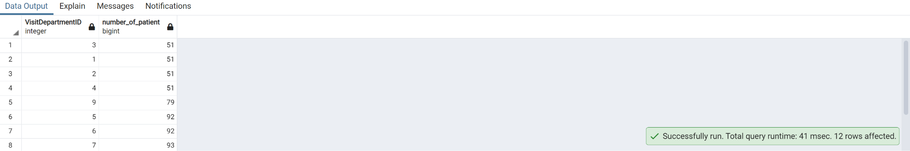

**33. Write a query to get list of patient names whose visit type is new and visitdepartmentId is 2.**

SELECT CONCAT("FirstName",' ', "LastName") As FullName

FROM public."Patients"

INNER JOIN public."AmbulatoryVisits" ON "Patients"."Patient_ID"="AmbulatoryVisits"."Patient_ID"

INNER JOIN public."VisitTypes" ON "AmbulatoryVisits"."AMVT_ID"=public."VisitTypes"."AMVT_ID"

where "VisitType"='New' and "VisitDepartmentID"=2;

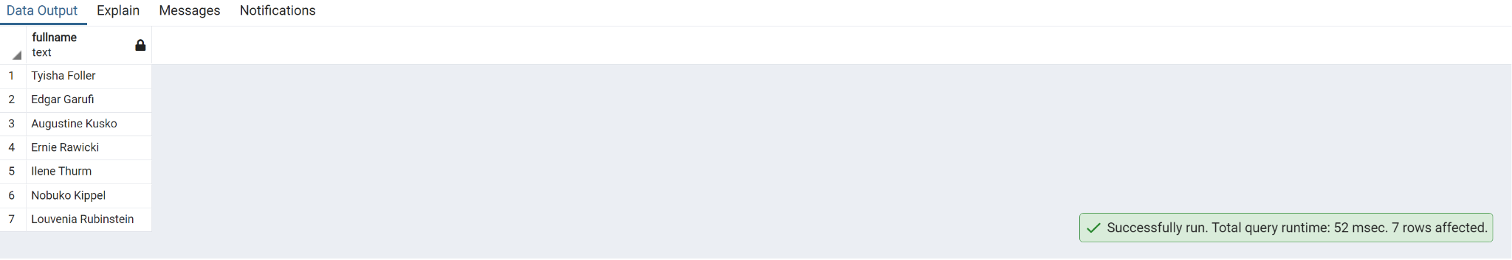

**34. Write a query to find the most common reasons for hospital visit for patients between 50 and 60 years**

select "ReasonForVisit", count(*) as "Number_Of_Visits"

from public."Patients" p

inner join public."EDVisits" ed on ed."Patient_ID" = p."Patient_ID"

inner join public."ReasonForVisit" rv on rv."Rsv_ID" = ed."Rsv_ID"

where date_part ('year', age("DateOfBirth")) >= 50 and date_part ('year', age("DateOfBirth")) <=60

group by "ReasonForVisit"

order by "Number_Of_Visits" desc

limit 1;

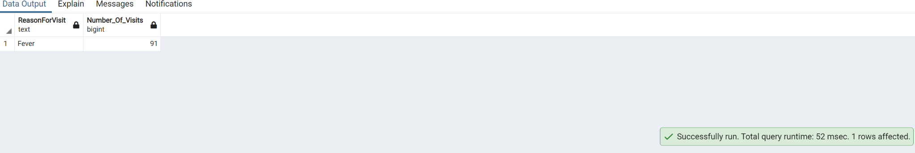

**35. Get list of Patients whose gender is Male and who speak English and whose race is White**

select concat ("FirstName",' ',"LastName") as "Full_Name","Gender", "Language", "Race"

from public."Patients" p

inner join public."Gender" g on g."Gender_ID" = p."Gender_ID"

inner join public."Race"r on r."Race_ID" = p."Race_ID"

inner join public."Language" l on l."Language_ID" = p."Language_ID"

where "Gender" = 'Male' and "Language" = 'English' and "Race" = 'White';

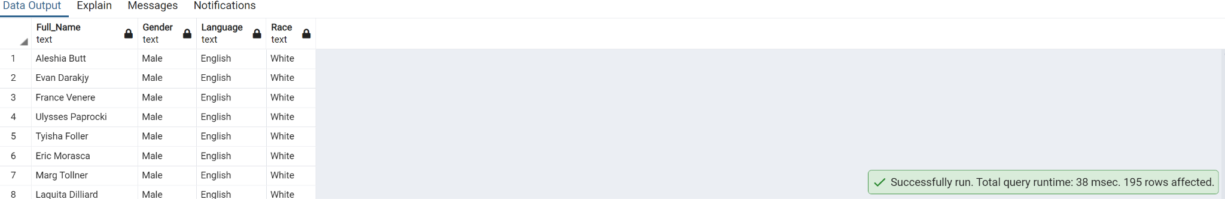

**36. Create index on Patient table**

CREATE INDEX idx_Patients

ON public."Patients" ("Patient_ID","Language_ID");

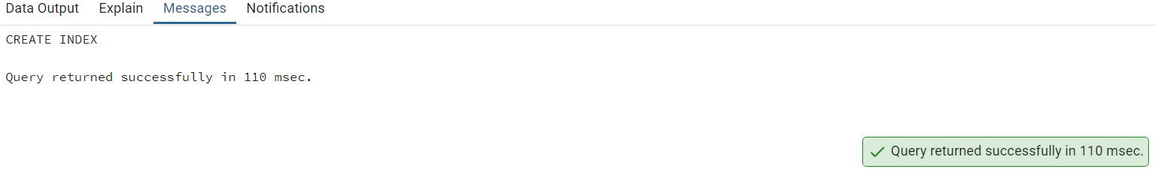

**37. Write a query to get list of Provider ID's where ProviderDateOnStaff year is 2013 and 2010**

select "Provider_ID", date_part ('year' , "ProviderDateOnStaff" ) from public."Providers"

where date_part ('year' , "ProviderDateOnStaff" ) in (2013 , 2010);

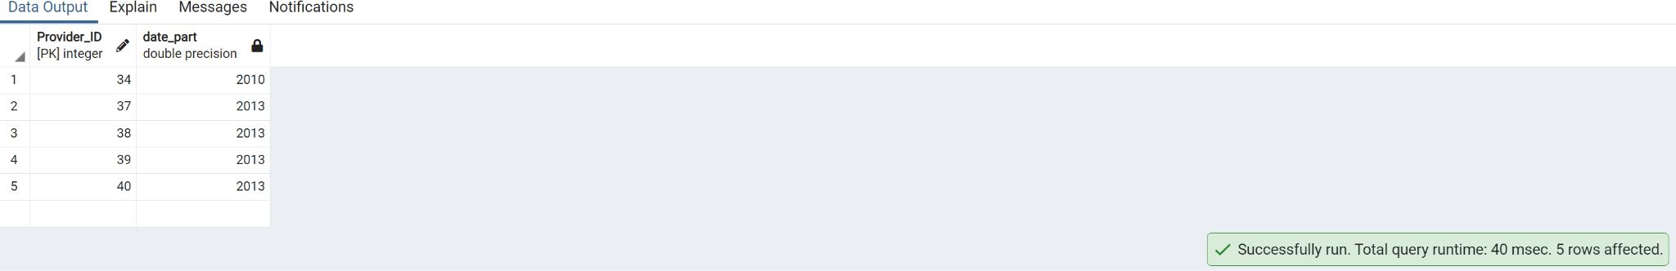

**38. Write a query to find out percentage of Ambulatory visits by visit type.**

select "VisitType", count (*) as "Frequency",

ROUND(

100 * COUNT(*) / SUM(COUNT(*)) OVER (),

2

) as "Percentage_Of_AmbulatoryVisit"

from public."VisitTypes" v

inner join public."AmbulatoryVisits" a on v."AMVT_ID" = a."AMVT_ID"

group by "VisitType"

order by "Percentage_Of_AmbulatoryVisit" DESC;

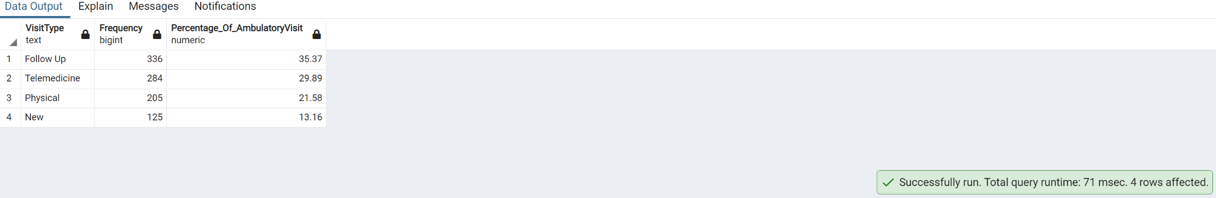

**39. Write a query to get list of patient names who has discharged.**

select p."FirstName", p."LastName", d."Patient_ID"

from public."Patients" p

right join public."Discharges" d on p."Patient_ID"=d."Patient_ID";

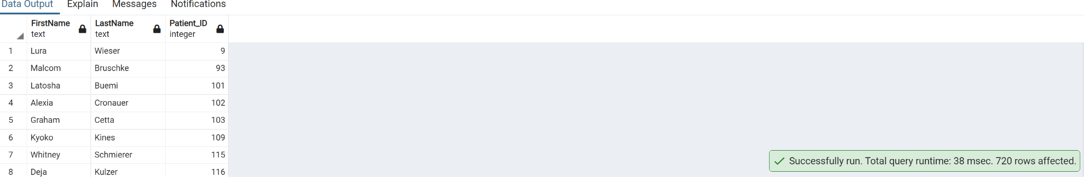

**40. Create view on table EdVisit by selecting some columns and filter data**

**using Where condition**

CREATE VIEW "ED_visit" AS

SELECT "EDVisit_ID","Patient_ID"

FROM public."EDVisits"

WHERE "Acuity" = 5;

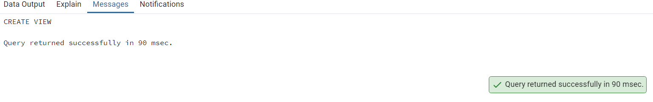

**41. Get list of patient names whose primary diagnosis as 'Spinal Cord injury'**

**having Expected LOS is greater than 15**

select concat ("FirstName",' ',"LastName") as "Full_Name",r."ExpectedLOS",ROUND(r."ExpectedLOS") as Length_of_Stay

from public."Patients" p

inner join public."ReAdmissionRegistry" r on p."Patient_ID" = r."Patient_ID"

left join public."PrimaryDiagnosis" d on d."Diagnosis_ID"=d."Diagnosis_ID"

where ROUND("ExpectedLOS") > 15 and d."PrimaryDiagnosis" = 'Spinal Cord Injury'

order by "Full_Name";

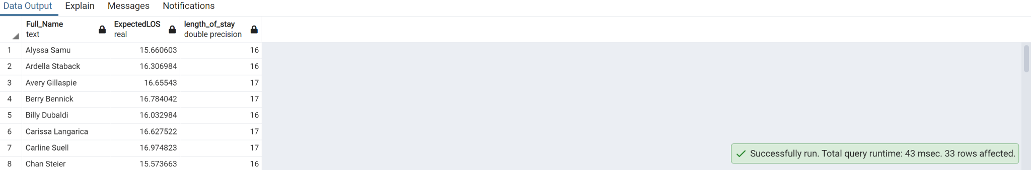

**42. Write a query to get list of Patient names who haven't discharged**

select "FirstName", "LastName", "Discharges"."Patient_ID" from public."Patients"

left join public."Discharges" on "Patients"."Patient_ID"="Discharges"."Patient_ID";

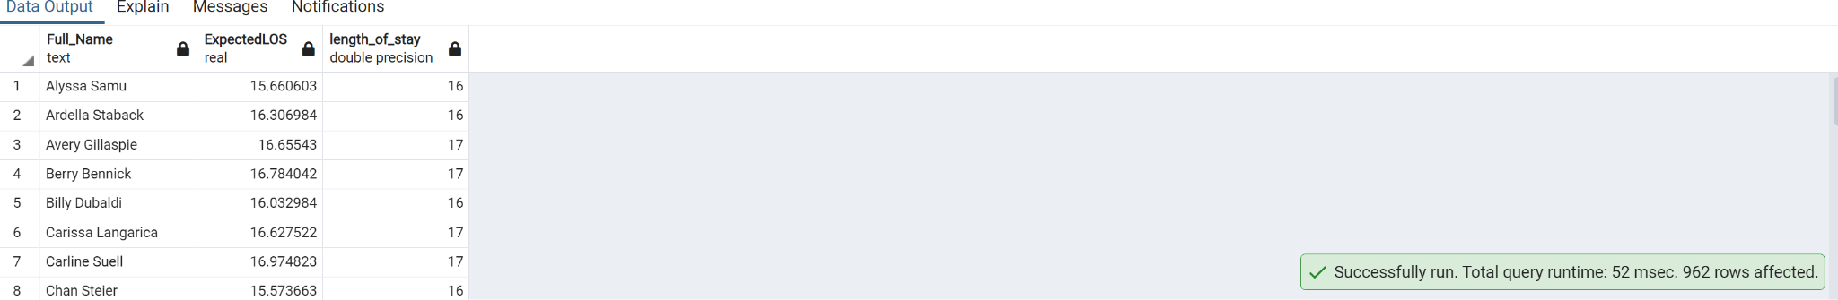

**43. Write a query to get list of Provider names whose ProviderSpecialty is**

**Pediatrics.**

select p."ProviderName", ps."ProviderSpeciality"

from public."Providers" p

inner join public."ProviderSpeciality" ps on p."PS_ID" = ps."PS_ID"

where "ProviderSpeciality" = 'Pediatrics';

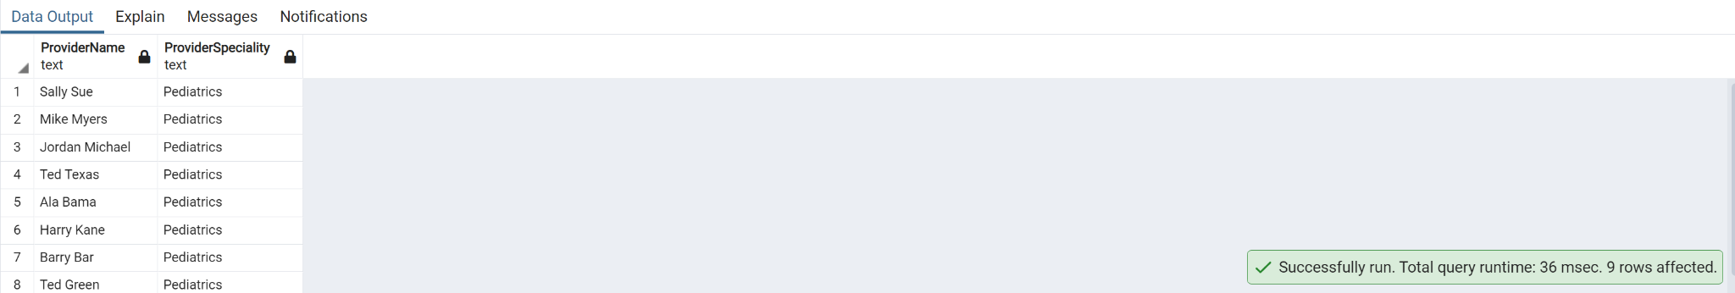

**44. Write a query to get list of patient ID's who has admitted on 1/7/2018 and**

**discharged on 1/15/2018**

select "Patient_ID" from public."ReAdmissionRegistry"

where TO_CHAR("DischargeDate", 'DD/MM/YYYY')= '15/01/2018'

and TO_CHAR("AdmissionDate", 'DD/MM/YYYY')= '07/01/2018';

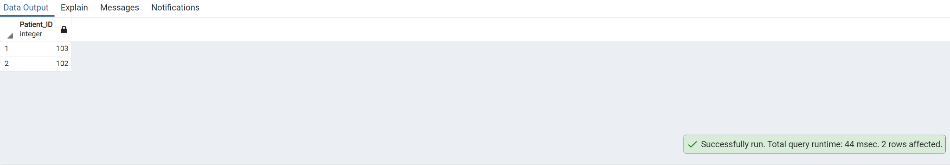

**45. Write a query to find outpatients vs inpatients by monthwise (hint:**

**consider readmission/discharges and ambulatory visits table for inpatients**

**and outpatients)**

select "month_name","monthnum", max(case when (type='Inpatients') then "total_patients" else 0 end) as Inpatients,

max(case when (type='Outpatients') then total_patients else 0 end) as Outpatients

from (

select 'Inpatients' as type,EXTRACT(MONTH FROM "DischargeDate") as MonthNum, to_char("DischargeDate", 'month') as month_name, count("Patient_ID") as Total_patients

from public."Discharges"

group by EXTRACT(MONTH FROM "DischargeDate") , to_char("DischargeDate", 'month')

union

select 'Outpatients' as type,EXTRACT(MONTH FROM "DateofVisit") as MonthNum, to_char("DateofVisit", 'month') as month_name, count("Patient_ID") as Total_patients

from public."AmbulatoryVisits"

group by EXTRACT(MONTH FROM "DateofVisit") ,to_char("DateofVisit", 'month')

--order by type, month_name

) a

group by "monthnum","month_name"

order by "monthnum";

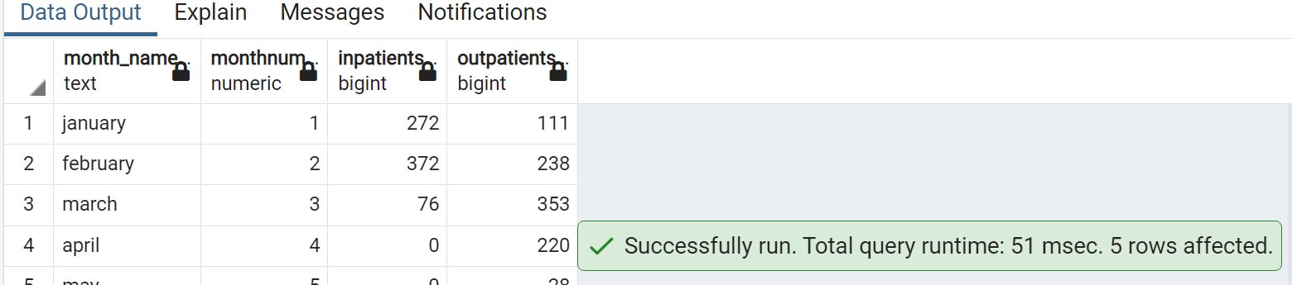

**46. Write a query to get list of Number of Ambulatory Visits by Provider**

**Speciality per month**

WITH cte_provider AS (

SELECT "ProviderSpeciality","Provider_ID"

FROM public."ProviderSpeciality"

INNER JOIN public."Providers" on "ProviderSpeciality"."PS_ID"="Providers"."PS_ID"

)

SELECT "ProviderSpeciality",TO_CHAR("DateofVisit", 'Month') AS "MonthName",date_part('month',"DateofVisit") AS "MonthNumber",COUNT(*) AS number_of_visits

FROM public."AmbulatoryVisits"

LEFT JOIN cte_provider USING("Provider_ID")

GROUP BY "ProviderSpeciality","MonthName","MonthNumber"

ORDER BY "ProviderSpeciality","MonthNumber";

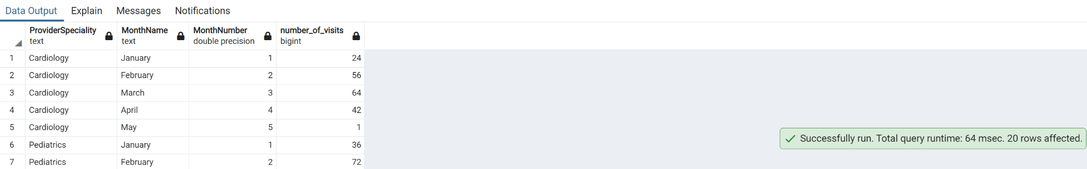

**47. Write a query to find Average age for admission by service**

select s."Service", ROUND(AVG(date_part('year', age("DateOfBirth")))) as "Average Age"

from "ReAdmissionRegistry" a

join "Patients" p on p."Patient_ID" = a."Patient_ID"

join "Service" s ON s."Service_ID" = a."Service_ID"

group by s."Service_ID";

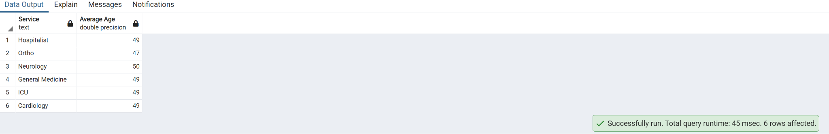

**48. Write a query to get list of patient with their full names whose names**

**contains "Ma"**

select "Patient_ID",CONCAT("FirstName",' ', "LastName") as "Full_Name"

from public."Patients"

where CONCAT("FirstName",' ', "LastName") like '%Ma%';

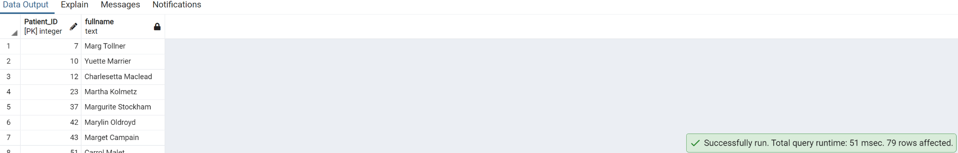

**49. Update Visit Timestamp column in EDVisits table by selecting data type as**

**timestamp with timezone**

ALTER TABLE public."EDVisits"

ALTER COLUMN "VisitTimestamp"

SET DATA TYPE timestamp with time zone;

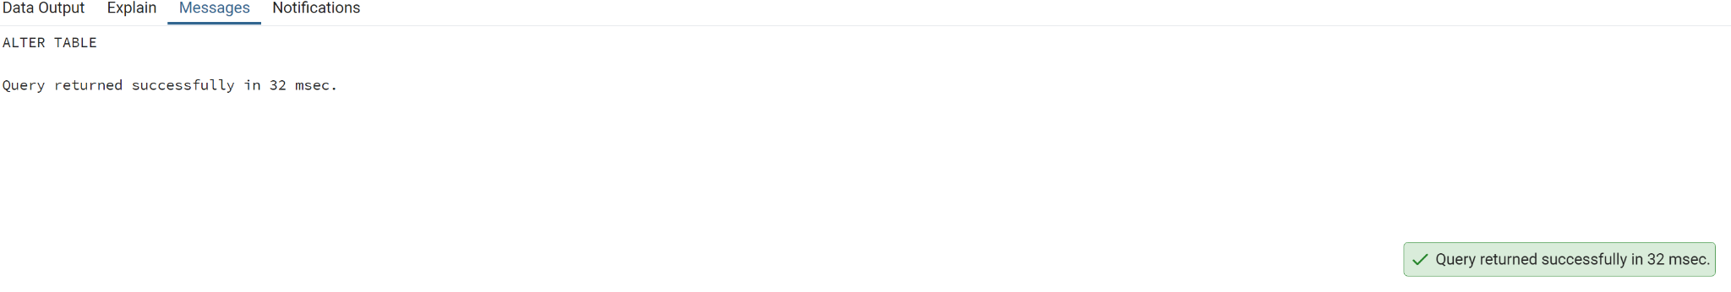

**50. Write a create a trigger function on AmbulatoryVisits by selecting any two**

**Columns.**

CREATE FUNCTION trigger_function()

RETURNS TRIGGER

LANGUAGE PLPGSQL

AS $$

BEGIN

IF NEW."DateofVisit" < '2018-11-09' and "VisitDepartmentID" = 10 THEN

update public."AmbulatoryVisits" set "BloodPressureSystolic"='0';

END IF;

RETURN NEW;

END;

$$

**51. Insert number of days for Readmission in DaysToReadmission Column for**

**patient ID's from 737 to 742(use any random value)**

update "ReAdmissionRegistry"

set "DaysToReadmission" = floor(random() * 9 + 1)

where "Patient_ID" >=737 and "Patient_ID" <= 742;

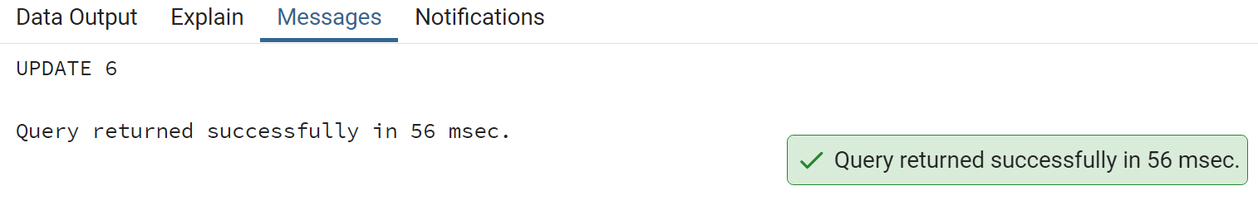

**52. Get list of Provider names whose name is starting with K and ending with y**

**(Hint:K-Upper, Y-Lower)**

SELECT "ProviderName"

FROM public."Providers"

WHERE INITCAP("ProviderName") like 'K%y';

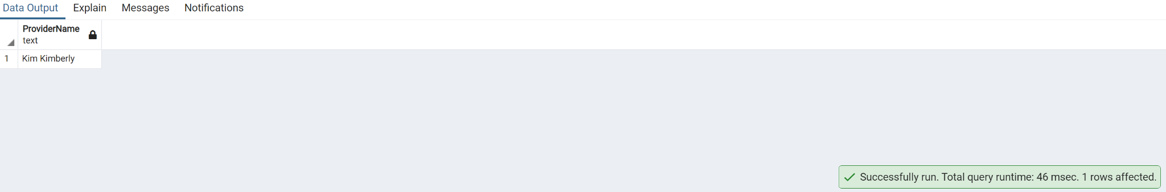

**53. Write a query to Split provider First name and Last name into different**

**Column**

select "ProviderName",split_part("ProviderName" ,' ',1) as First_name, split_part("ProviderName" ,' ',2) as Last_name

from public."Providers"

order by "ProviderName";

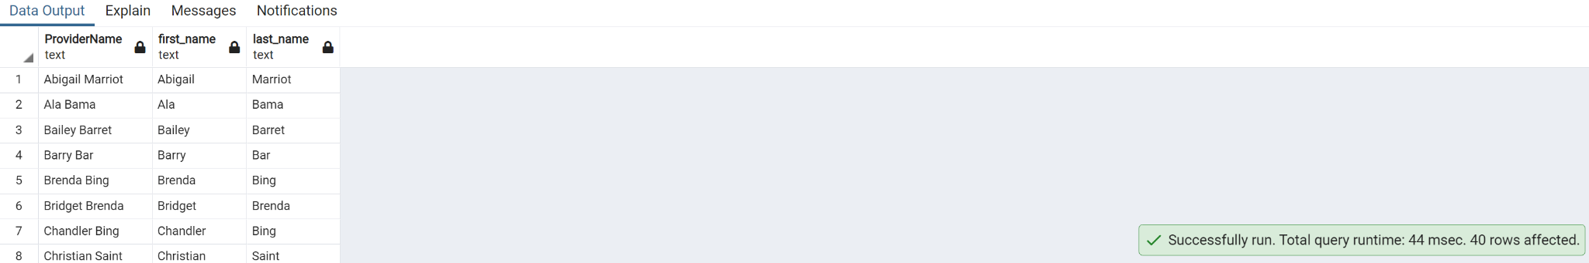

**54. Get list of Patient ID's order by Discharge date**

select "Patient_ID","DischargeDate",TO_DATE(TO_CHAR("DischargeDate", 'YYYY-MM-DD'),'YYYY-MM-DD') AS "Discharge_Date"

from public."Discharges"

order by "Discharge_Date";

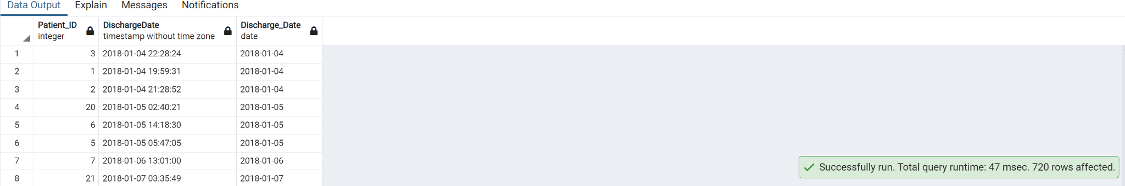

**55. Write a query to drop View by creating view on table Discharge by selecting**

**Columns**

create view "Patient_Discharge" as

select "Patient_ID","AdmissionDate","DischargeDate"

from public."Discharges"

where "Patient_ID" < 100

--select * from "Patient_Discharge"

drop view "Patient_Discharge"

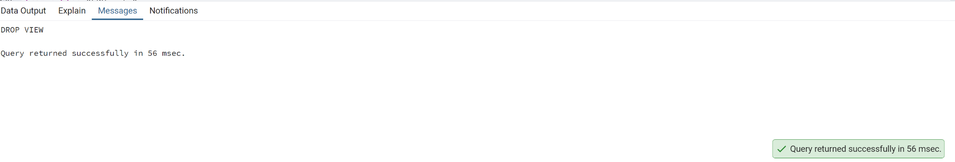

**56. Write a query to get list of Patient ID's where Visitdepartment ID is 1 and**

**BloodPressureSystolic is between 123 to 133**

select "Patient_ID","VisitDepartmentID","BloodPressureSystolic"

from public."AmbulatoryVisits"

where "VisitDepartmentID"=1 and "BloodPressureSystolic" between 123 and 133

order by "Patient_ID";

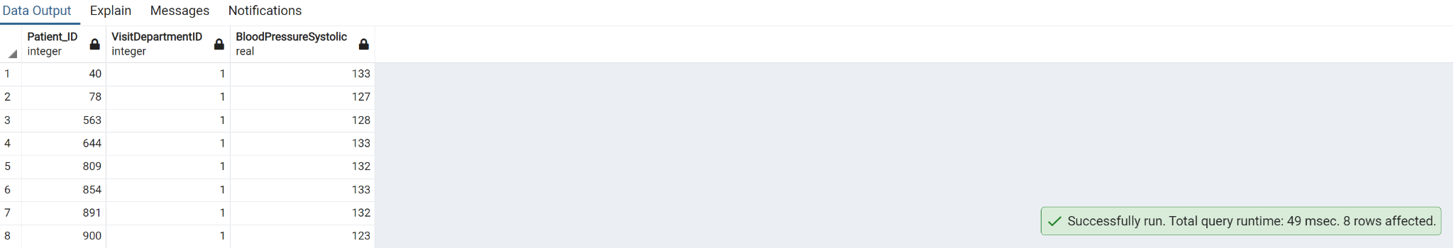

**57. Write the query to create Index on table ReasonForVisit by selecting a**

**column and also write the query drop same index**

create index ReasonForVisit_index 1

on public."ReasonForVisit"("ReasonForVisit");

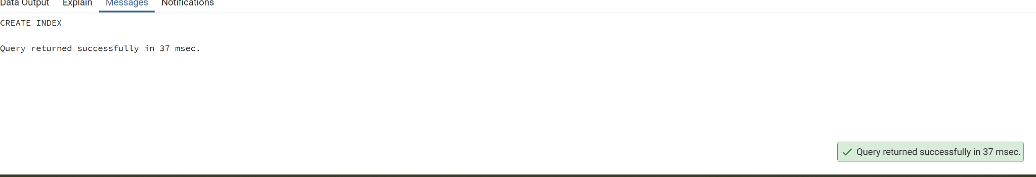

**drop index ReasonForVisit_index;**

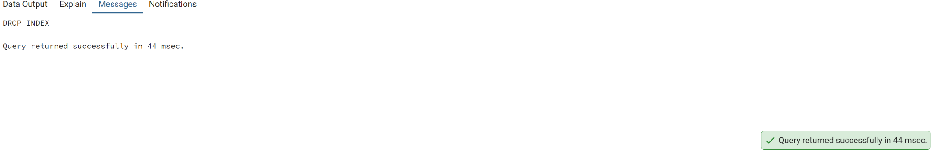

**58. Write a query to Count number ofunique patients EDDisposition wise.**

select "EDDisposition",count(distinct "Patient_ID") as no_of_patients

from public."EDVisits" e

inner join public."EDDisposition" ed on e."EDD_ID"=ed."EDD_ID"

group by "EDDisposition"

order by no_of_patients;

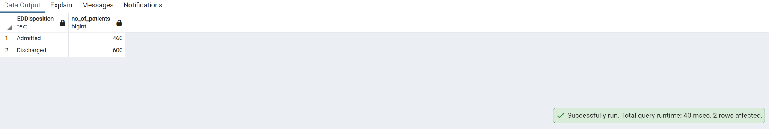

**59. Write a query to get list of Patient ID's whree Visitdepartment ID is 5 or**

**BloodPressureSystolic is NOT NULL**

select "Patient_ID","VisitDepartmentID","BloodPressureSystolic"

from public."AmbulatoryVisits"

where "VisitDepartmentID"=5 or "BloodPressureSystolic" is not null;

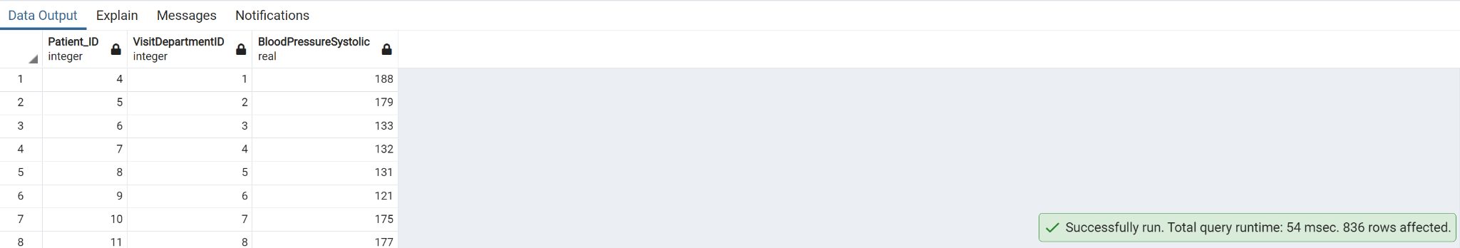

**60. Query to find the number of patients readmitted by Service**

select tbl2."Service", count (distinct tbl1."Patient_ID") as No_Of_Patients

from public."ReAdmissionRegistry" as tbl1

inner join public."Service" as tbl2 on tbl1."Service_ID"=tbl2."Service_ID"

group by 1

order by 1;

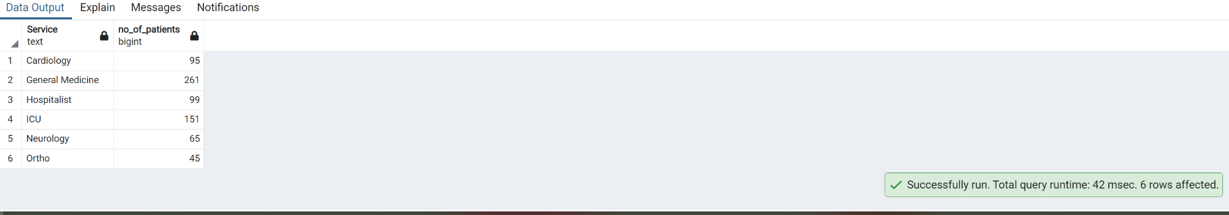

**61. Write a query to list male patient ids and their names who are above 40**

**years of age and less than 60 years and have BloodPressureSystolic above**

**120 and BloodPressureDiastolic above 80**

select a."Patient_ID",p."FirstName",p."LastName",date_part('year', age("DateOfBirth")) AS "Age"

from public."Gender" g

inner join public."Patients" p on p."Gender_ID"=g."Gender_ID"

right join public."AmbulatoryVisits" a on p."Patient_ID"= a."Patient_ID"

where "Gender" ='Male' and (date_part ('year',age("DateOfBirth")) >40 and date_part ('year',age("DateOfBirth"))<60)

AND "BloodPressureSystolic" > 120 and "BloodPressureSystolic" > 80

ORDER BY "Age";

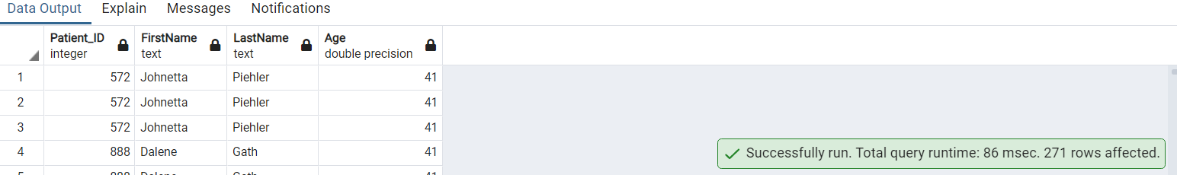

**.62 Query to find the number of out patients who have visited month wise(use month names)**

SELECT TO_CHAR("DateofVisit", 'Month') AS "MonthName",COUNT(*) AS out_patient

FROM public."AmbulatoryVisits"

GROUP BY "MonthName",date_part('month',"DateofVisit")

ORDER BY date_part('month',"DateofVisit");

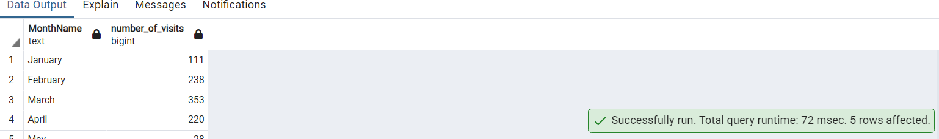

**63. Write a query to get list of patient ID's whose BloodPressureSystolic is**

**131,137,138**

select "Patient_ID", "BloodPressureSystolic"

from public."AmbulatoryVisits"

where "BloodPressureSystolic" in (131, 137,138)

order by "Patient_ID";

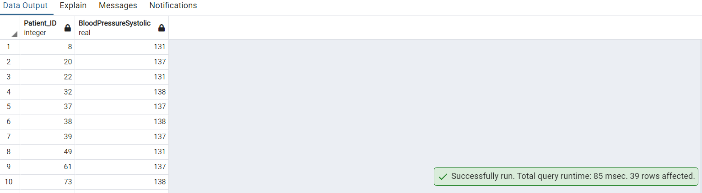

**64. Query to classify expected LOS into 3 categories as per the duration. (Hint:**

**Use of CASE statement)**

with cte_duration as (

SELECT "Patient_ID","ExpectedLOS",

CASE

WHEN "ExpectedLOS" <=6 THEN 'Short'

WHEN "ExpectedLOS" <=12 THEN 'Medium'

WHEN "ExpectedLOS" <=17 THEN 'Long'

END "Duration"

FROM public."Discharges"

ORDER BY "ExpectedLOS"

)

select "Duration", count (*) as num_of_patients

from cte_duration

group by "Duration"

order by "Duration" DESC;

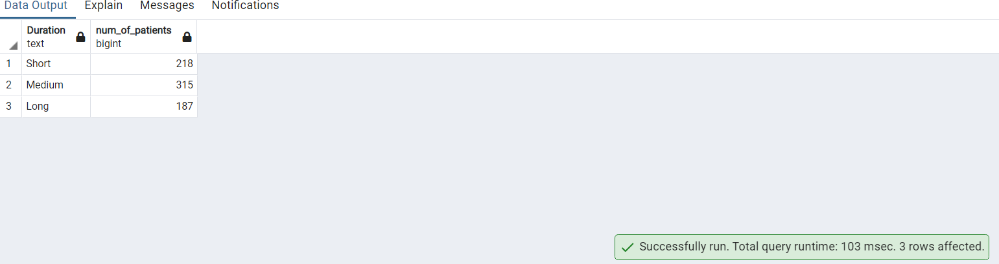

**65. Write a query to create a table to list the names of patients whose date of**

**birth is later than 1st jan 1960.Name the table as “Persons”**

CREATE TABLE "Persons" AS

SELECT

"FirstName",

"LastName",

"DateOfBirth"

FROM

public."Patients"

WHERE

"DateOfBirth" > '1960-01-01';

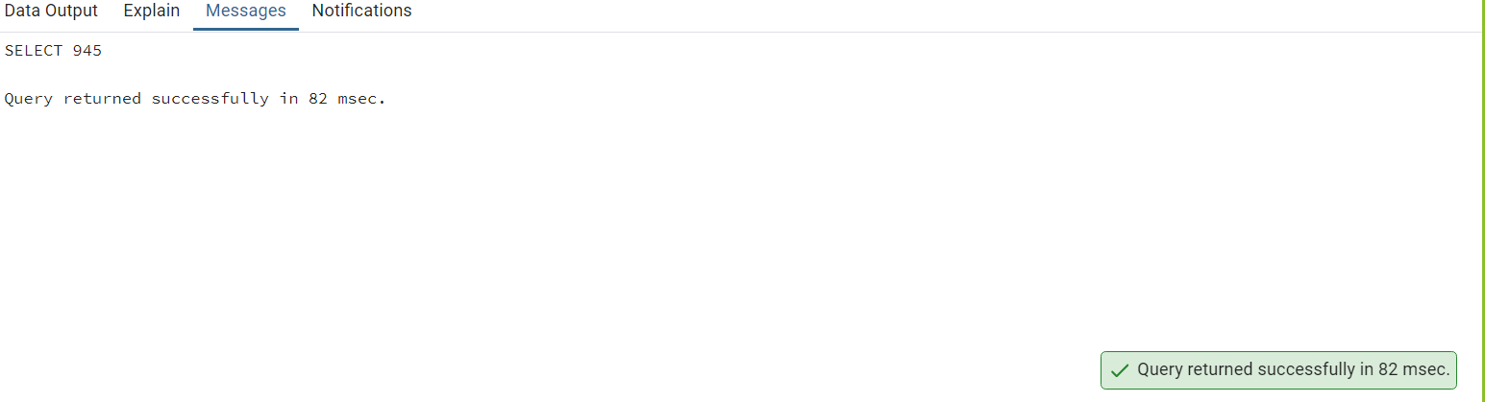

select * from "Persons"

order by "FirstName";

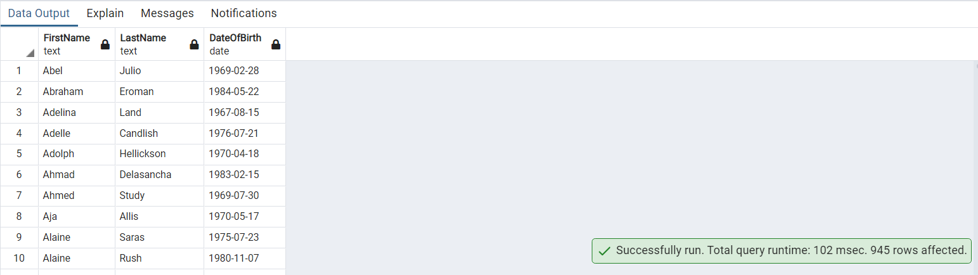

**66. Write a query to Count number of patients who has discharged after**

**march3rd 2018**

select count(*) as number_of_patients

from public."Discharges"

where "DischargeDate" > '2018-03-03';

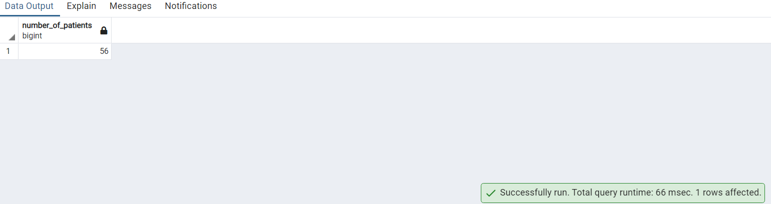

**67. Replace ICU with emergency (Hint: Do not update or alter the table)**

SELECT

case when "Service" = 'ICU' then 'emergency' else "Service" end as "Service","Service_ID"

from public."Service";

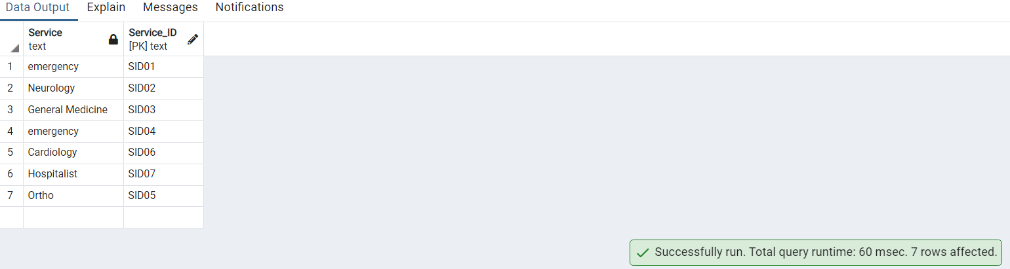

**68. Write a query to get Sum of ExpectedLOS for Service_ID 'SID01'**

select "Service_ID", ROUND(sum ("ExpectedLOS")) as "Total_ExpectedLos"

from public."ReAdmissionRegistry"

where "Service_ID" = 'SID01'

group by "Service_ID";

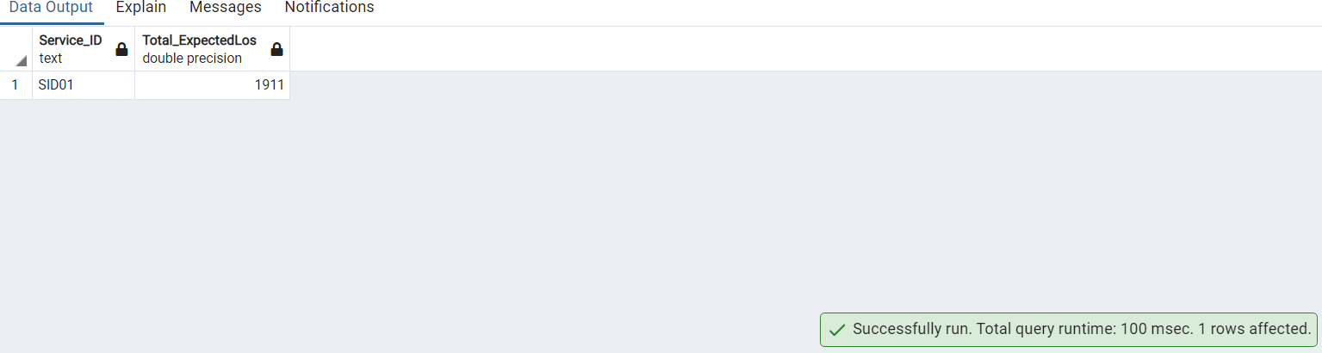

**69. Create index on table Provider by selecting a column and filter by using**

**WHERE condition**

create index idx_provider on public."Providers" ("Provider_ID")

where "Provider_ID" = 1;

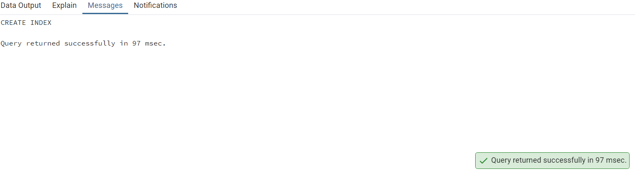

**70. List down all triggers in our HealthDB database**

SELECT event_object_table AS table_name ,trigger_name

FROM information_schema.triggers

GROUP BY table_name , trigger_name

ORDER BY table_name ,trigger_name

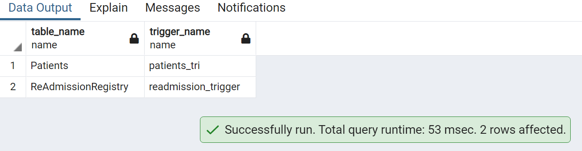

**71. Partition the table according to Service_ID and use windows function to**

**calculate percent rank. Order by ExpectedLOS.**

select "Service_ID" , "ExpectedLOS",

ROUND(

(PERCENT_RANK() OVER (

PARTITION BY "Service_ID"

ORDER BY "ExpectedLOS"

))::NUMERIC, 5

)as percent_rank

from public."ReAdmissionRegistry"

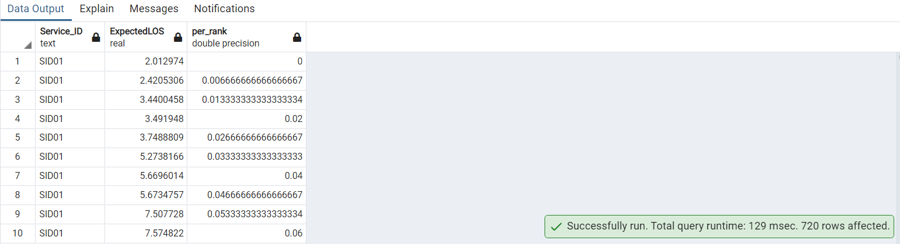

**72. Write a query by using common table expressions and case statements to**

**display birthyear ranges**

with cte as (

select "Patient_ID","DateOfBirth",

extract ('year' from "DateOfBirth") as birth_year,

case when extract ('year' from "DateOfBirth") between 1960 and 1969 then '1960-1969'

when extract ('year' from "DateOfBirth") between 1970 and 1979 then '1970-1979'

when extract ('year' from "DateOfBirth") between 1980 and 1990 then '1980-1990'

end as birth_year_range

from public."Patients"

order by birth_year

)

select birth_year_range, count(*) as number_of_patient from cte

group by birth_year_range

order by number_of_patient;

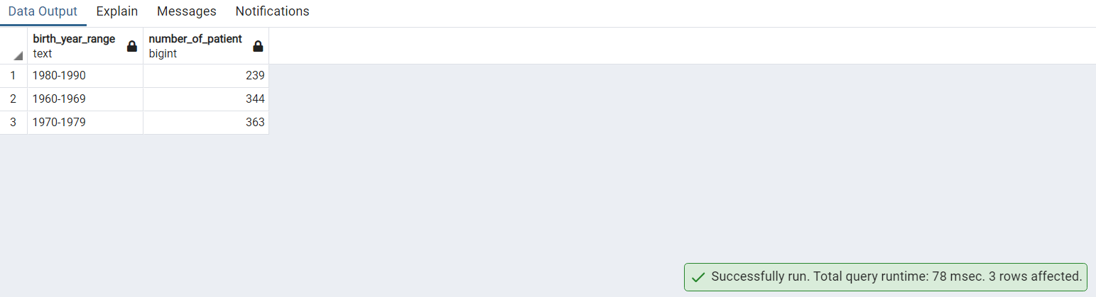

**73. Get list of Provider names whose ProviderSpeciality is Surgery**

select p."ProviderName",ps. "ProviderSpeciality"

from public."Providers" p

inner join public."ProviderSpeciality" ps on p."PS_ID" = ps."PS_ID"

where "ProviderSpeciality" = 'Surgery';

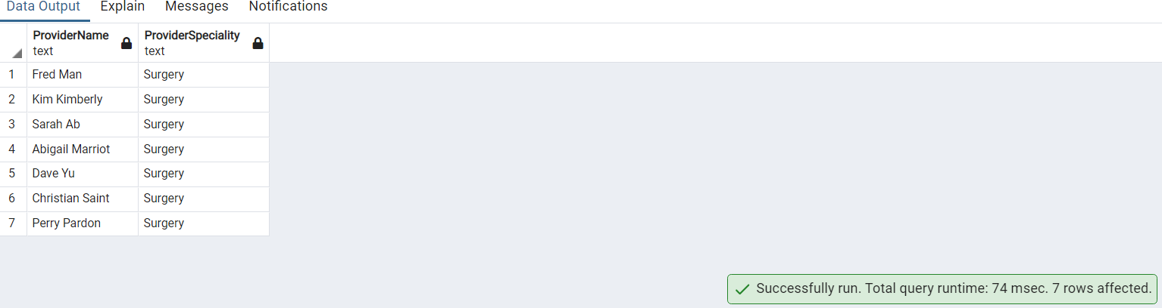

**74. List of patient from rows 11-20 without using where condition.**

select * from public."Patients"

OFFSET 10 ROWS

FETCH FIRST 10 ROW ONLY

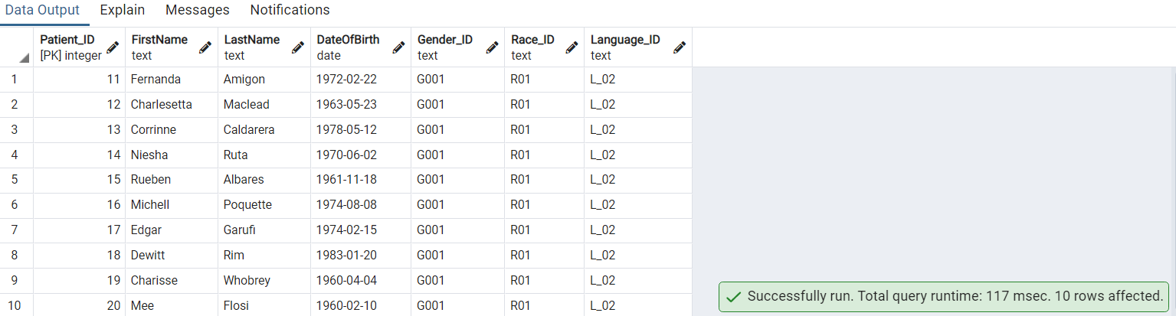

**75. Give a query how to find triggers from table AmbulatoryVisits**

SELECT event_object_table AS table_name ,trigger_name

FROM information_schema.triggers

where event_object_table = 'AmbulatoryVisits'

GROUP BY table_name , trigger_name

ORDER BY table_name ,trigger_name

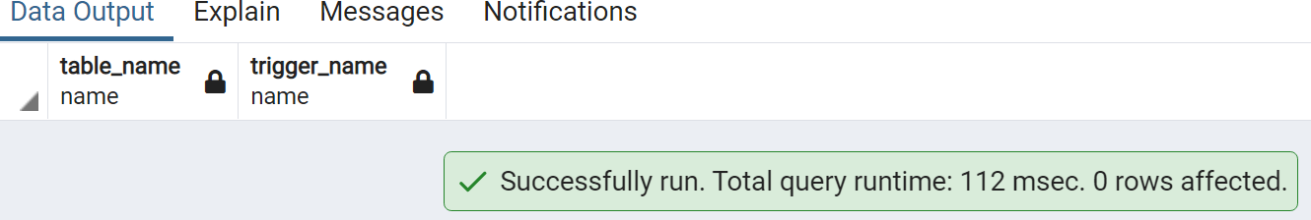

**76. Recreate the below expected output using Substring.**

select "Gender", substring("Gender",1,1) as gender from public."Gender**";**

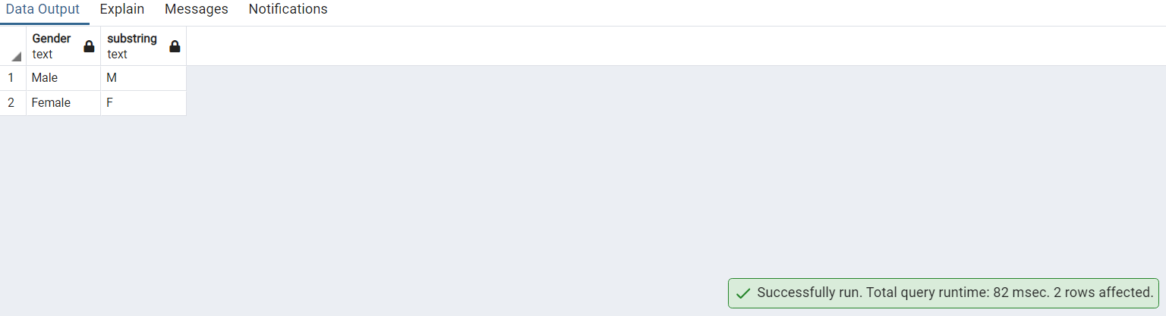

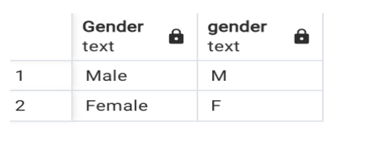

**77. Obtain the below output by grouping the patients.**

select "Patient_ID","FirstName", substring("FirstName",1,1) as patient_group

from public."Patients"

where "FirstName" like 'L%'

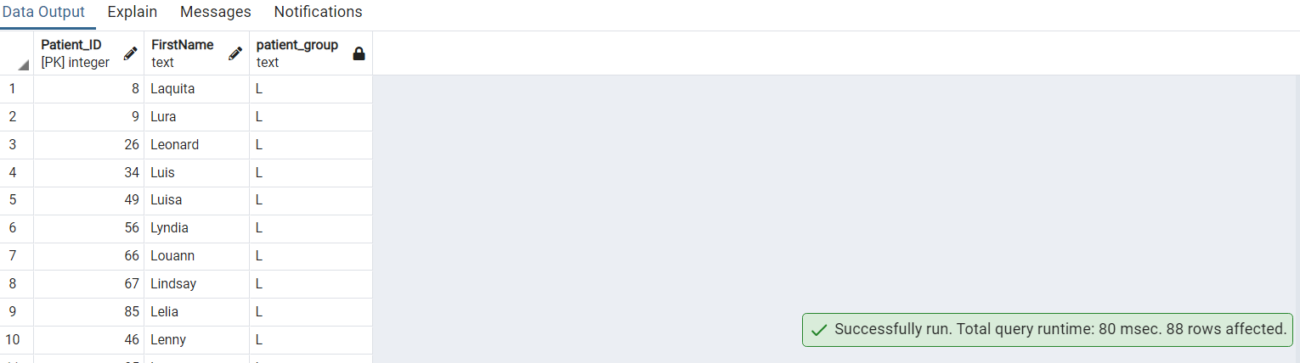

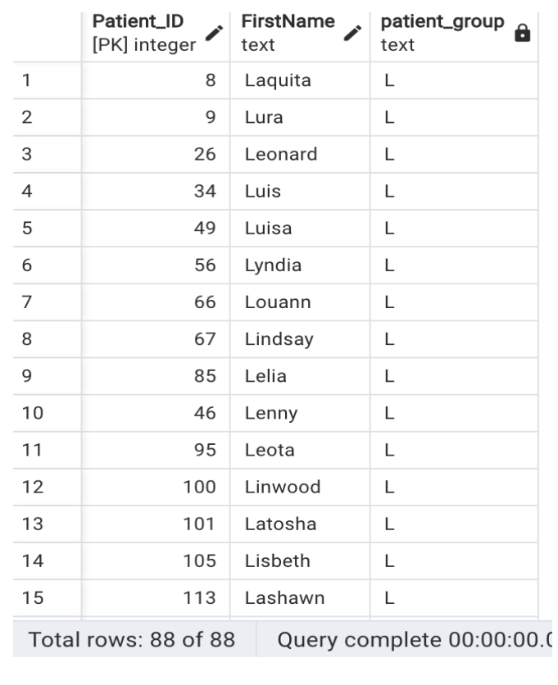

**78. Please go through the below screenshot and create the exact output.**

select "FirstName", LENGTH("FirstName") as unknown from public."Patients"

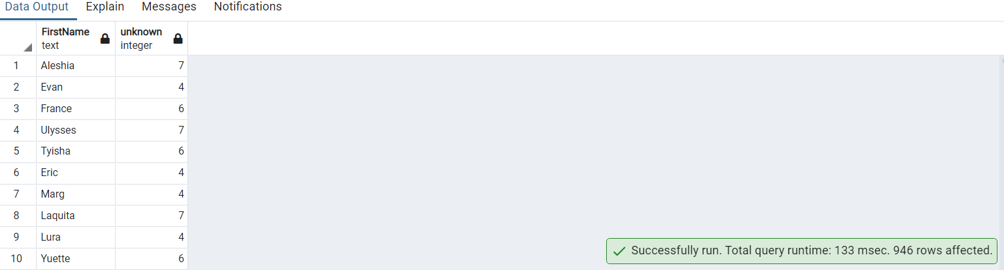

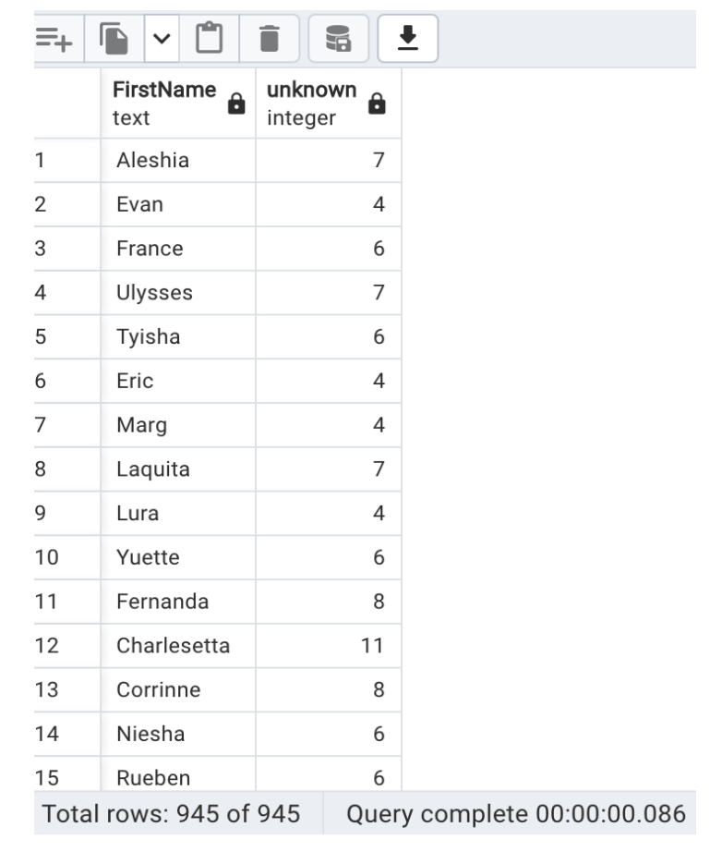

**79. Please go through the below screenshot and create the exact output**

select "BloodPressureDiastolic","Pulse",ceiling("BloodPressureDiastolic")as bpd ,floor("Pulse") as heartrate

from public."AmbulatoryVisits"

OFFSET 1 ROWS

FETCH FIRST 21 ROW ONLY

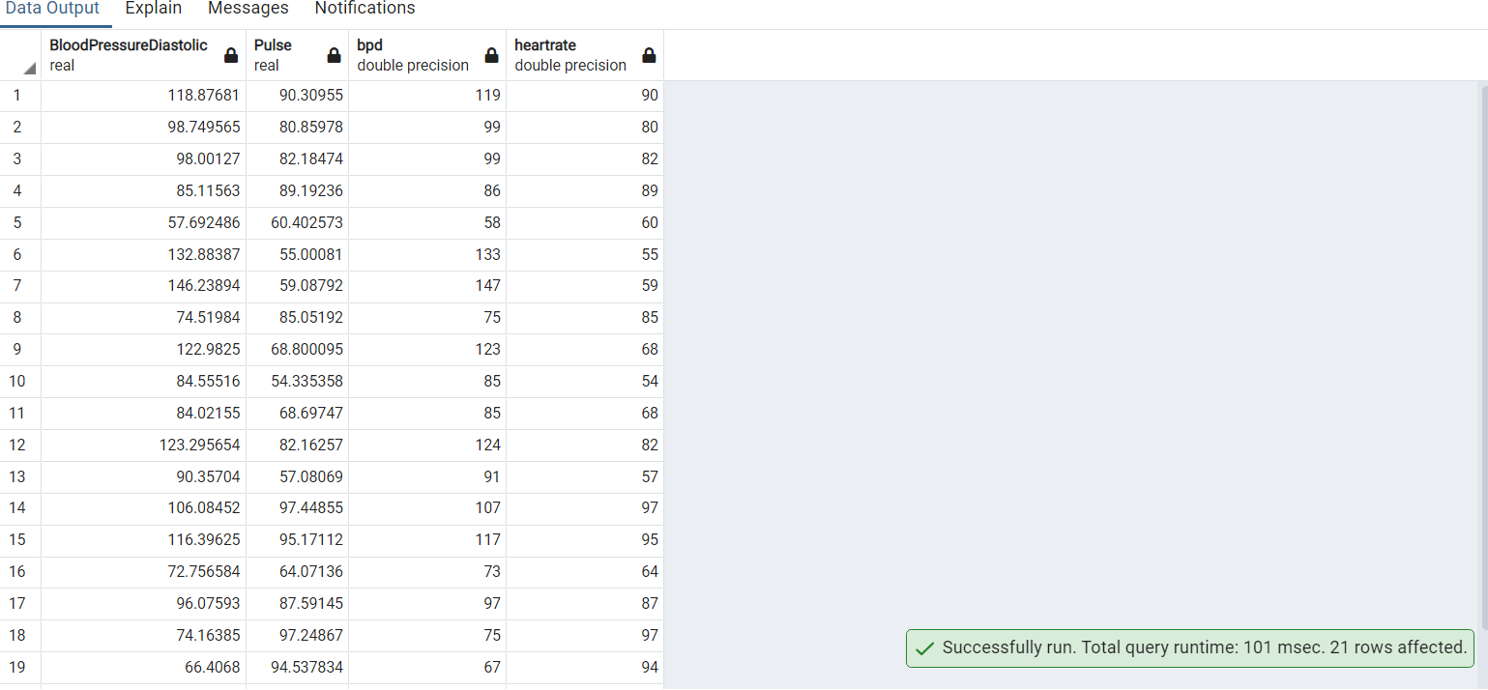

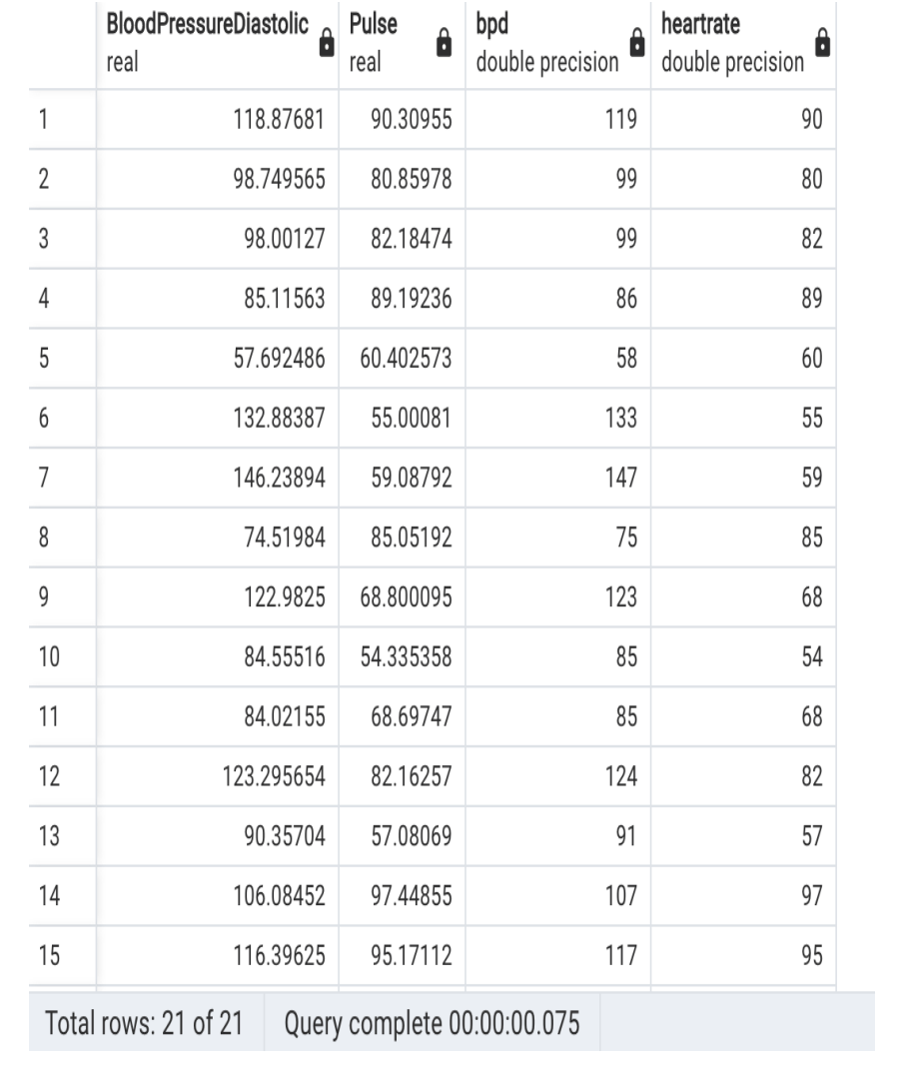

**80. Please go through the below screenshot and create the exact output**

select "BloodPressureSystolic", CONCAT('The Systolic Blood pressure is ',round(CAST("BloodPressureSystolic" AS NUMERIC), 2)) as Message from public."AmbulatoryVisits"

